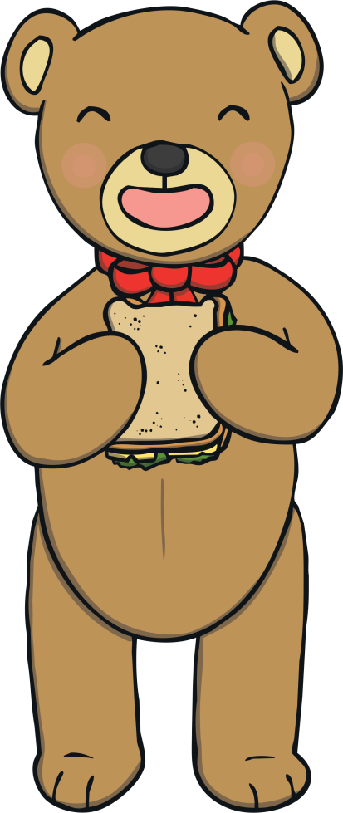

Hello children,

My name is Buttons the Bear. I have a special invitation for you! I would like to invite you and your favourite teddy bears to a teddy bears’ picnic!

I need your help to make invitations, picnic food and decorations. Please can you help me? What food could we have? What decorations could we make? What are your teddy bears called?

Our picnic will be on:

Time:

Place:

I hope you have lots of fun!

From Buttons the Bear