Room 4 Monday 20th April 2020:

Here is your work for the week. Do as much as you can, but don’t feel pressured to complete everything. Try to do reading, fine motor, gross motor and life skills every day if you can.

20/04/2020 | Monday | Tuesday | Wednesday | Thursday | Friday
Reading
Life skills
Gross Motor and PE
Fine Motor
Extra activity
(Art, SESE, Baking)

Reading:
Go to www.twinkl.com and search for The Cautious Caterpillar ebook. Read this book with/to your child.
Answer the following questions orally:
- What season is it?
- What is the caterpillar’s name?
- What can ladybirds do?
- What do bees eat?
- How many legs does a grasshopper have?
- How many legs does Cody have?
- What did Cody change into first?
- When she left her Chrysalis, what had she become?
- How did she feel at the start of the story?
- How does she feel at the end of the story?

There are differentiated comprehension worksheets attached to this story on twinkl. If you have a printer you can print these worksheets and complete them. (note; Please read through these comprehension sheets before you print them and gauge what level your child will be able to complete)

Life Skills: Please use the board below to choose 3 activities every day this week

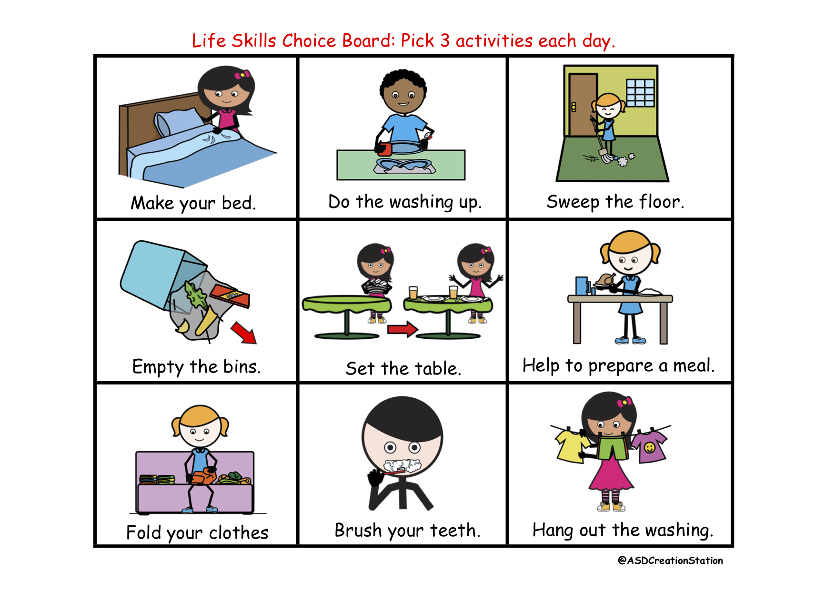

Gross Motor Skills: Please ue the Board below to choose 3 activities every day this week
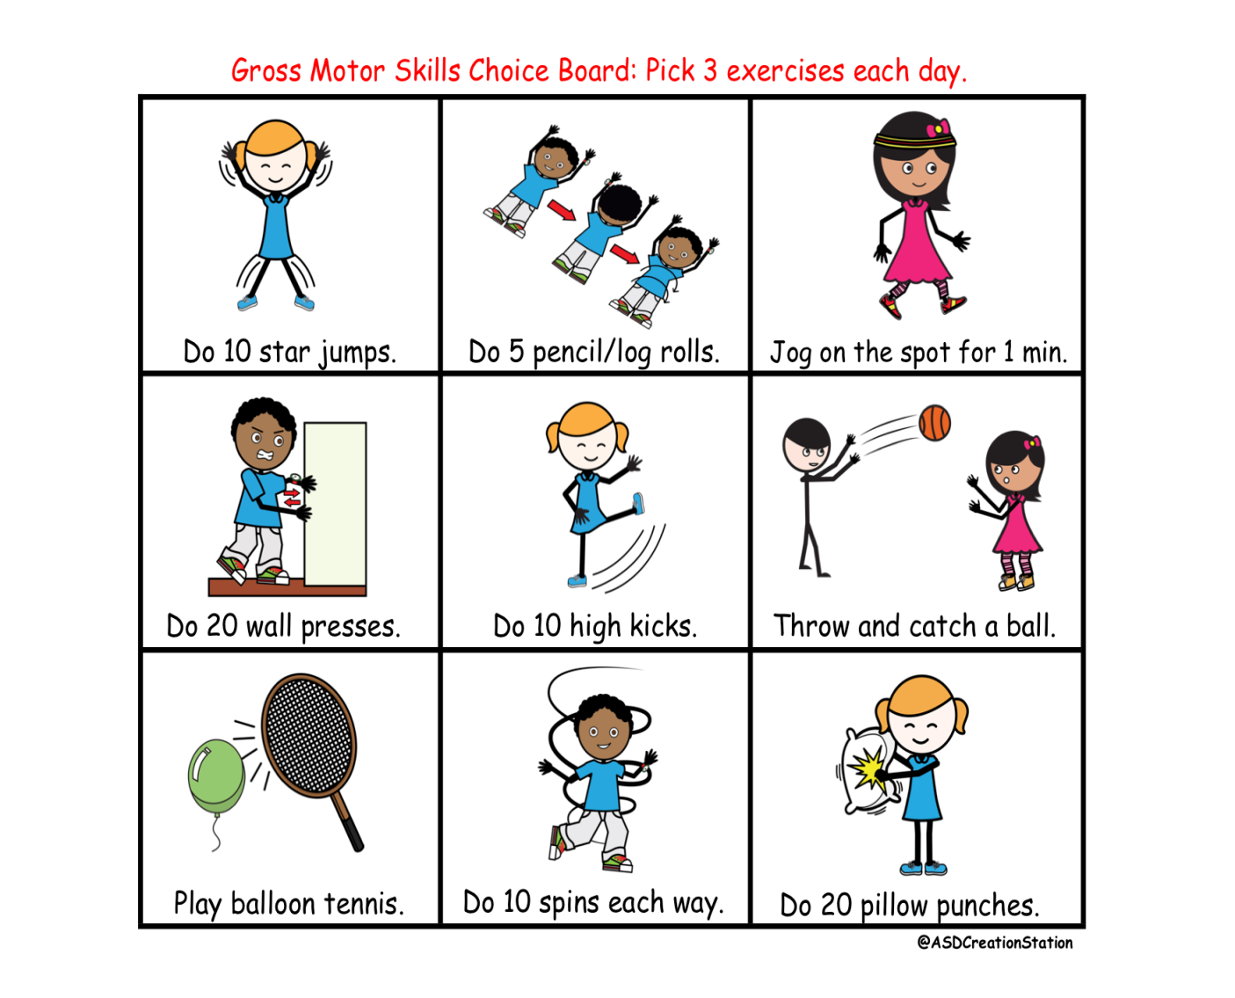

P.E.

1: Use the gross Motor activity choice board every day.
2: On Tuesday complete one ‘Cosmic kids’ yoga activity.
3: On Thursday go to www.gonoodle.com to find dance activities to complete.
4: Try to go for a walk every day and look for signs of spring and new baby animals.
5. Use the link on web page to do Joe Wicks Workout every day

Fine Motor Skills: Please Choose 3 activities to complete from the board below every day
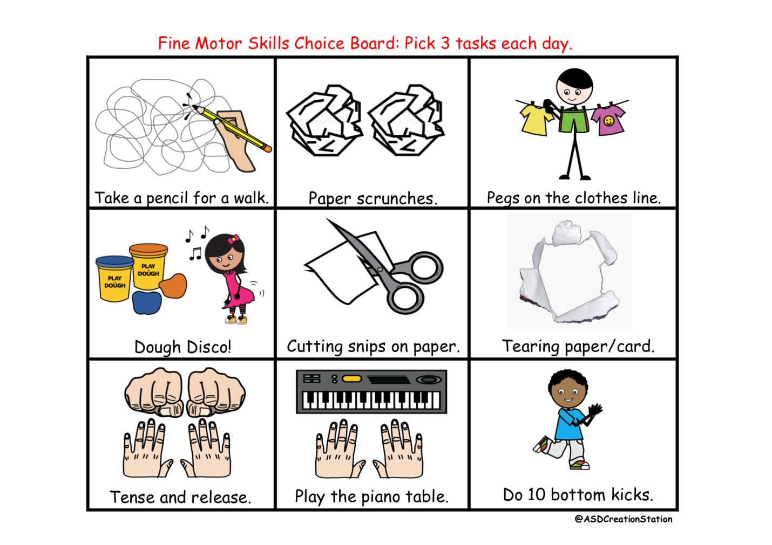

Art:
Painting a symmetrical butterfly - You will need paper, paint, a paintbrush and a scissors.

1: Fold a piece of paper in half.
2: Have an adult draw the outline of half a butterfly on one side.
3: Paint the wings on this ‘half’ butterfly using nice bright colours. Add a pattern if you wish.
4: Fold the page back over again so that the painted side prints onto the blank side of the paper.
5: Once dry cut your butterfly out and colour in the body.
6: Once complete cut out your butterfly.

You can also go to www.twinkl.com and search ‘butterfly pattern symmetry worksheet’ if you do not have paint.

Baking Soda Bread: This is an easy to use recipe that requires a little assistance. You need an regular empty clean dry tin (from beans or tinned tomatoes) to measure the ingredients and measuring spoons.
Ingredients: 1 tin of wholemeal flour
1 tin of white plain flour
1 tin can of milk (buttermilk if you can get it)
1 handful of porridge oats
1 teaspoon of salt
1 teaspoon of honey
2 teaspoons of bicarbonate of soda
Mix all the ingredients together in a bowl and knead together while dusting with flour.
Dust the countertop with flour and knead the mixture some more. Shape it into a circle and place on a baking tray. Score it with a knife making an x on the top. Brush with olive oil or a beaten egg and lightly sprinkle some more porridge oats over the top. Bake in the oven for 30-35 minutes at 200C until golden and crisp. Allow to cool for 10 minutes and eat warm with butter and Jam!

SESE:

Spring on the Farm
We had been doing work on farm animals and spring time before school finished up. Please search for the following activities on www.twinkl.com to continue this work:

- Mothers and their young farm animals matching activity
- Phonics level 3 spring at the farm picture worksheet
- Farm animals worksheet

Life cycle of a butterfly
Go to www.twinkl.com and search for the following

- The Cautious Caterpillar - life cycle of a butterfly powerpoint
- Life cycle of a butterfly cut and paste worksheet
- KS1 Life Cycle of a Butterfly Differentiated Reading Comprehension Activity (note; please read through these activities before you print and gauge what level you child will be able to work through)

