Hi everyone, I have assigned only four days work again this week as you can choose a day this week to complete your own sports day. There will be lots of exercises and challenges put up on the school website for you to use. I will also attach a document with a list of activities for you to use. I have also created another virtual school tour for you to try out this week! I hope you have fun!
Please send me on photos and videos of all the fun activities you get up to at s.haughney@scoilmhuireleixip.com
Enjoy the day!
Happy Monday 22nd June! : )
English
1. Write your news from the weekend and draw a picture.
2. Read P. 29-30 of Jasper Saves the day.
3. Spelling Workbook: Unit 10– exercise 1 and 2
4. Spelling list 32: put one word from the spelling list into a sentence

Maths
- Mental Maths: Week 36 Monday and the problem
- Tables: Revise -2
- Planet Maths: p 155

P.E Take part in 30 minutes of exercise; play in the garden, go for a walk or take part in one of Joe Wick’s PE lessons on YouTube.
Tuesday 23rd June
English
- Jasper Saves the Day page 31 and 32
- Spelling Workbook: Unit 10 exercise 3
- Spelling list 32: Put one word from today’s spellings into a sentence.
- Handwriting: Complete the next letter in your handwriting book. If you have all the letters completed copy one of the sentences from the book into your handwriting copy.
Maths
- Mental Maths: Week 36 Tuesday and the problem
- Tables: Revise -2
- Planet Maths: page156

Well-Being:
Use the following link to complete a short meditation task - https://www.youtube.com/watch?v=9A0S54yAgEg7

SESE: I have created a online quiz which you can complete with your parents or your brothers and sisters.
- Go to www.kahoot.it
- Enter the following pin: 01188230
- Enter your name.
- Good luck

Well done for all your hard work today!
Wednesday 24th June

English
- Jasper Saves the Day page 33 and 34
- Oral language: look at the picture on page 34. Think of 3 different words for how the blue team and the red team might feel.
- Spelling workbook: Unit 10 exercise 4 and 5
- Spelling list 32: Put one word from today’s spellings into a sentence.

Well-Being
This week we are going to complete a My Self Care Plan. Fill out the plan on the attached worksheet.
Maths
- Mental Maths: Week 36 Wednesday and the problem
- Tables: Revise -3
- Planet Maths: page 160
Art:
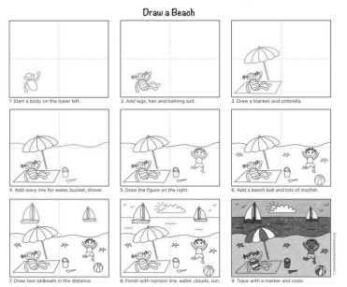

Thursday 25th June
English:
- Jasper Saves the Day page 35 and 36
- Spelling workbook: Unit 10 exercise 6
- Spelling test: spelling list 32
- Handwriting: Complete the next letter in your handwriting book. If you have all the letters completed copy one of the sentences from the book into your handwriting copy.

Maths
- Mental Maths: Week 36 Thursday and the problem.
- Friday Review

PE: Complete 30 minutes of exercise.
Well done on all your hard work this week.

