Active schools week: This week we celebrate active schools week. Try to do one piece of exercise every day.
Monday 27th April
Happy Monday! : )
English
1. Write your news from the weekend and draw a picture.
2. Read P. 37-38 the story ‘Sleep tight’.
3. Spelling Workbook: Unit 6 – exercise 1 and 2
4. Spelling list 24: put one word from the spelling list into a sentence

Maths
- Mental Maths: Monday p. 56 and the problem
- Tables: -5
- Complete the following sums into your copy. Remember to label your columns with T and U for tens and units.
Gaeilge
- Bua naCainte – An Teilifís Ceacht 4 - Click on the yellow speech bubble and select Comhrá. Press play and listen to the lesson.
- Complete Tasc Éisteachta 4.2
- Go to p. 68 of your book and carry out the reading the page out loud. (Chuala mé...) I heard...

Religion Theme 8: Lesson 2 - Sign up to ‘Grow in Love’ and access the 1st class materials. (Email address: trial@growinlove.ie Password: growinlove)
- Watch the video ‘Pentecost’ and talk about it with your family.

P.E Take part in 30 minutes of exercise; play in the garden, go for a walk or take part in one of Joe Wick’s PE lessons on YouTube.
Active schools week: “Marathon Monday”
- See how many laps of your garden you can do in the day!
- Challenge other members of your family.
Tuesday 28th April
English
- Read the story ‘Sleep tight’ P.39-40
- Write a list of the things you would bring with you if you were going camping. This can be done in any copy or on a page.
- Spelling Workbook: Unit 6 exercise 3
- Spelling list 24: Put one word from today’s spellings into a sentence.
Maths
- Mental Maths: Tuesday p.56 and the problem
- Tables: -5
- Planet Maths: p.140
Part B: Look at the example on the class page.
e.g 7+7= 14. We ‘carry’ the tens (1) up to be added in with the other ‘tens’. Remember all the ‘tens’ have to stay together and all the ‘units’ have to stay together. We write ‘tens’ under the ‘tens’ column and ‘units’ under the units column. Look at the videos on the class page to help if you are stuck.
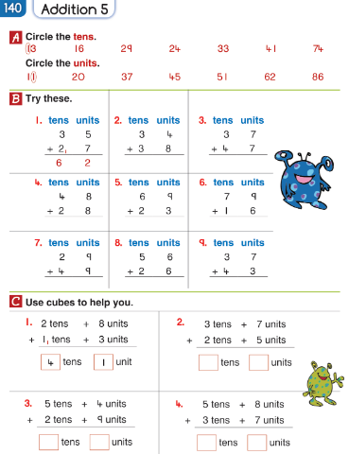

Gaeilge: Teílifís Cleacht 4
- An Teilifís Ceacht 4: Click on the yellow speech bubble and listen to the lesson again.
- Complete Tasc Éisteachta 4.2
- Complete P.69 in Bua na Cáínte
Religion: Theme 8 Lesson 2
- Complete p.46 in G.I.L workbook.
SESE: The farm
- Read and answer the questions into a copy and draw a picture.
1. What animals do dairy farms have?
2. What do people use crops to make?
3. What do chickens eat?
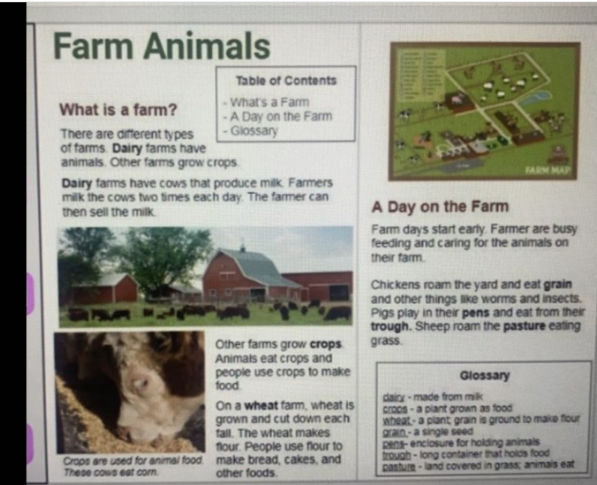

Active School Week: “Target Tuesday”
- Using whatever equipment you have, set up a target challenge for your family in the garden.
- For example: How many footballs/tennis balls/toilet rolls can you get in to the bucket?

Well done for all your hard work today!
Wednesday 28th April

English
- Read ‘Sleep tight’ p.40
- Spelling workbook: Unit 6 exercise 4
- Spelling list 24: Put one word from today’s spellings into a sentence.
- Verbs: go through the PowerPoint on verbs. Complete the worksheet on verbs. You can print it out or write the sentences into a copy. Ask someone at home to play verb tennis with you! Think of all our bossy verbs we used in school.

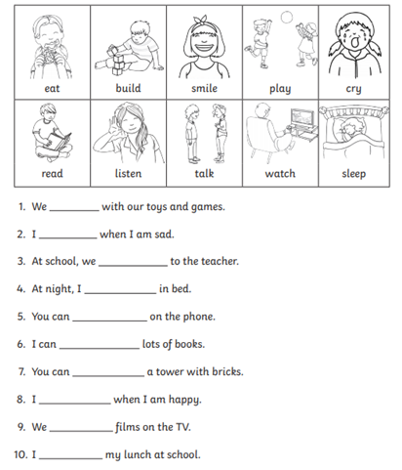

Maths
- Mental Maths: Wednesday and the problem p.56
- Tables: -5
- Complete the following sums in your copy or on a page.

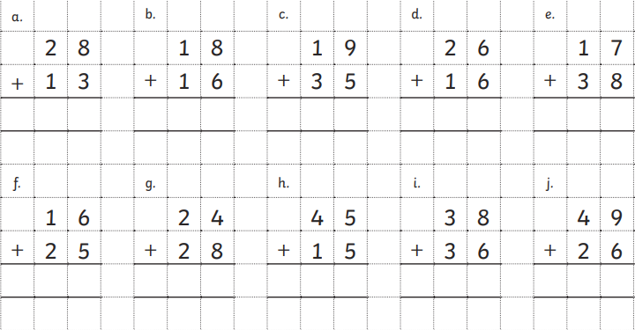

Gaeilge: Cleacht 5- comhra 5.1
- Listen to the lesson.
- Play tasc éisteachta 5.1
- Listen to the ‘rann’ by clicking the green music icon.
If you cannot access Bua na Cainte online: look at page 70 for the vocabulary and practise saying the sentence ‘Feicim...’ (I see...)
Religion: Theme 8 Lesson 2
- Complete p.47 in G.I.L workbook
Art:
As today is Wednesday, we would usually be doing Art. Below I have attached a sample if you want to give it a go! The faded blue lines show where you should fold your page in 4…this will help you layout the picture as they have done. All you need is an A4 piece of paper, a pencil and some colours!
Active School Week: “Walk On Wednesday”
- Be sure to get out for a walk with your family today.
- You could organise the pre walk warm up and cool down for the family.
- Younger children might like to bring their favourite teddy on their walk today

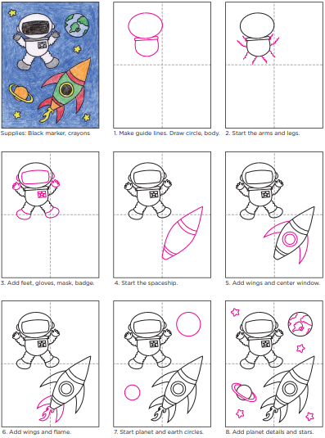

Well done on all your hard work so far, you are half way through the week!

Thursday 29th April

English
- Spelling list 24: Put one word from today’s spelling list into a sentence.
- Spelling workbook: Unit 6 ex 5
- Reading: pages 37-39 (Sleep Tight)
- Procedural Writing: Watch the video on how to eat an Oreo on the class page. Do you twist it? Do you dunk it? Write the procedure and draw pictures. Remember each step starts with a bossy verb!
Use the sheet below if you would like or write it into a copy or on a page.
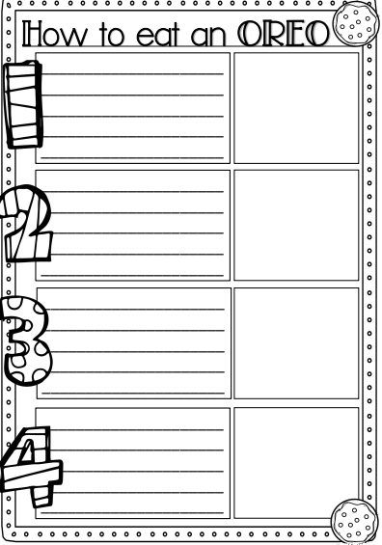
Maths
- Mental Maths: Thursday p.57 and the problem.
- Tables: -5
- Planet Maths: p.141 Part A: Make sure you label your ‘tens’ and ‘units’. Add units together first and then add tens. When this is done regroup your tens and units. Counters/pencils may be used to help.
Write the sums into a copy or print out the page below.

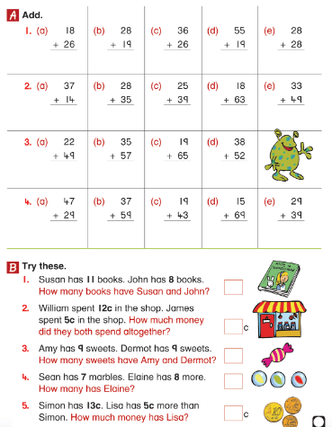

Gaeilge: Cleacht 5- comhra 5.2
- Listen to the lesson and play tasc éisteacht 5.2
- Listen to the ‘rann’ again by clicking the green music icon.
- Complete P.70 in Bua na cainnte.
SESE: People who help us
Now, more than ever we have lots of people helping to keep us safe and healthy. Even though we can’t see them because we are staying in our houses-they are working very hard. Can you name some of the different jobs that help us? Make a list. Use the PowerPoint to help you. How are these people helping us now? Read the clues below and draw the person doing their job on a page. (Spilt an A4 page into quarters and draw a person in each box, use the back of the page too)
- I help people when they are sick. I give them medicine.
- I work with children. I give them homework.
- I keep people safe. I work in a station. I drive a car with a siren.
- I help sick animals. I visit zoos and farms.
- I drive lots of people to lots of different places all day long. I often have many people in my vehicle.
- I go to lots of different houses. I deliver letters.
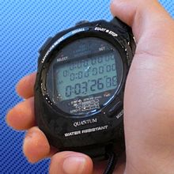
Active School Week: “Timing Thursday”
- Get the stopwatch ready: See how many of the following you can do in 1 minute?
- Jumping Jacks
- Frog Jumps
- Squats
- Lunges
- Scissors
- “Keepy uppies”
- Toe taps
- Challenge other members of your family!

Well done today! That’s Thursday’s work done which means tomorrow is Friday!

Friday 29th April
Happy Friday!
English:
- Spelling workbook: Unit 5 exercise 6 and 7
- Spelling test: spelling list 24
- Reading: Read pages 40-41 (Sleep Tight)
- Skills Book: Complete the worksheet below on ‘Sleep tight’. This can be printed out, written into a copy or completed orally.
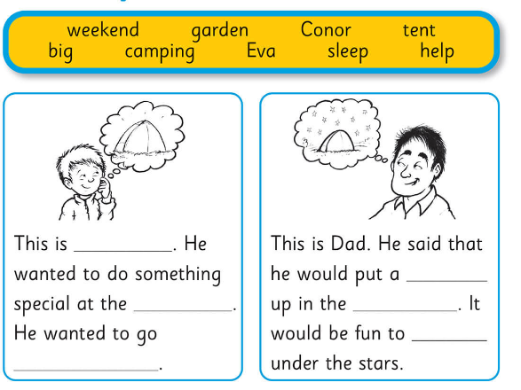
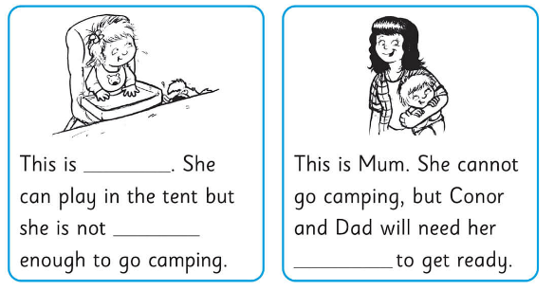

Maths
- Mental Maths: Friday Review p.57
- Table test
17-5= 6-5= 13-5=
9-5= 10-5= 15-5=
7-5= 12-5= 16-5=
14-5= 8-5=
5-5= 11-5=
Gaeilge: Cleacht 6
- Complete the worksheet below by drawing the correct program on the T.V screens. This can be printed out or draw by the child onto a page.
PE: Complete 30 minutes of exercise.
Active School Week: “Fun Friday”
- Create an obstacle course for your family in the garden, using household and garden items (kitchen chairs, pots, laundry basket, dustbin, garden pots, buckets, a pillow case as a sack etc.)
- Who will be the fastest family member to complete it?

