Monday 11th May
I hope you all had a lovely weekend : )
English
1. Write your news from the weekend and draw a picture.
2. Read P. 56 the story ‘Who invented LEGO’.
3. Spelling Workbook: Unit 7 – exercise 1 and 2
4. Spelling list 26: put one word from the spelling list into a sentence

Maths
- Mental Maths: Week 30 Monday and the problem
- Tables: -7
- Have a look at some coins. (2c, 5c, 10c, 20c)
Complete the following worksheet by drawing the coins into the piggy banks or you can place the real coins in them. This sheet can be drawn or printed out.

Gaeilge
- Bua naCainte – An Teilifís Ceacht 48 - Click on the yellow speech bubble and select Comhrá. Press play and listen to the lesson.
- Complete Tasc Éisteachta
Religion Theme 9: Lesson 1- Sign up to ‘Grow in Love’ and access the 1st class materials. (Email address: trial@growinlove.ie Password: growinlove)
- Watch the video ‘What is your favourite animal’ and then chat about your favourite animal with your family.
Great work today!
Tuesday 28th April
English
- Read the story ‘Who invented LEGO’ P.57
- Spelling Workbook: Unit 7 exercise 3 and 4
- Spelling list 26: Put one word from today’s spellings into a sentence.
Maths
- Mental Maths: Week 30: Tuesday and the problem
- Tables: -7
- Planet Maths: p.151
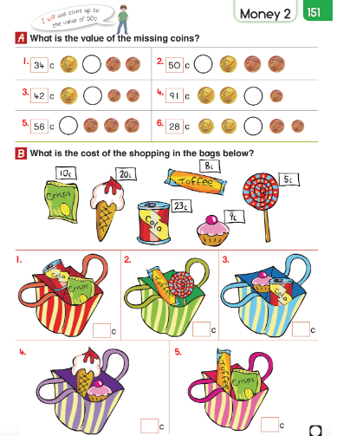

Gaeilge: Teílifís Cleacht 8
- An Teilifís Ceacht 8: Click on the yellow speech bubble and listen to the lesson again.
- Complete P.74 in Bua na Cáínte
Religion: Theme 9 Lesson 1
- Listen to the ‘Creation story’
- Complete p.50 in G.I.L workbook.

SESE: Sounds
- Complete the worksheet below on sounds. This can be done orally or printed out. Can you think of another soft and loud sound?
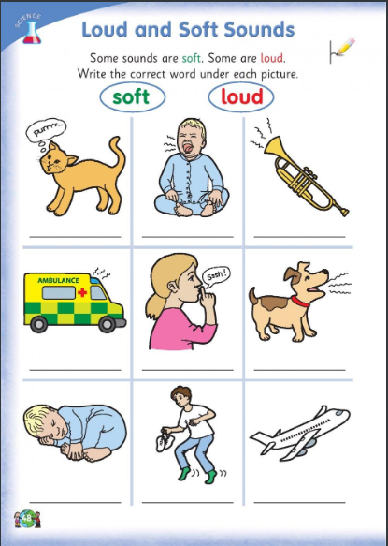

Wednesday 28th April
English
- Read ‘Who invented Lego?’ p56 and 57
- Spelling workbook: Unit 7 exercise 5
- Spelling list 26: Put one word from today’s spellings into a sentence.

Maths
- Mental Maths: Week 30 Wednesday and the problem
- Tables: -7
- Planet maths: P.152 – On this page, we will be finding out how much change we get when we buy something. For this, we will count on or taking away. You can use your number line.
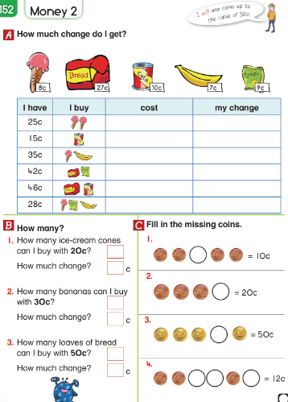

Gaeilge:
- Listen to the ‘scéal’. This is in the bottom left corner.
Religion: Theme 9 Lesson 1
- Complete p.51 in G.I.L.
Art: There are 2 options this week.
- Musical instrument: See attached document for instructions.
- Drawing: Below I have attached a sample of a drawing if you want to give it a go! 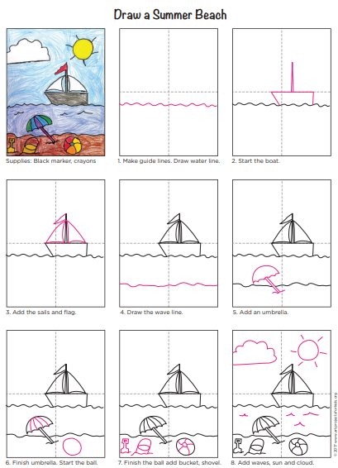

Thursday 29th April
English
- Read p 58 ‘Where does chocolate come from?’
- Spelling list 26: Put one word from today’s spellings into a sentence.
- Alphabetical order: Revise the alphabet by saying it out loud. Complete the following exercise.

Maths
- Mental Maths: Week 30 Thursday and the problem.
- Tables: -7
- Complete the worksheets below. These can be printed out or drawn into a copy.

Gaeilge:
- Listen to the scéal again.
- Complete P.75 in Bua na cainnte.
SESE: Sounds
- Think of the different sounds you might hear in different rooms in your house.
Can you think of 3 things that make noise in the kitchen, TV room and garden?
Complete the worksheet below by drawing some animals you might hear at the zoo on a page.
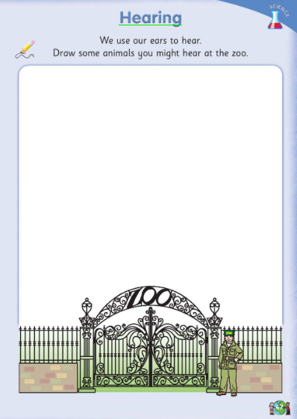

Friday 29th
^{Happy Friday!}
English:
- Read ‘Where does chocolate come from?’ p 58 and p59
- Spelling workbook: Unit 7 exercise 6 and 7
- Spelling test: spelling list 26
- Skills book: Complete following worksheet. It can be printed out or done onto a blank page.

Maths
- Mental Maths: Week 30 Friday Review
- Table test
17-7= 13-7=
9-7= 10-7= 15-7=
7-7= 12-7= 16-7=
19-7=
14-7= 8-7=
18-7= 11-7=
P.E.
Complete 30 mins of exercise.

Have a great weekend.
Well done on all your work this week!

