Do what you can, don’t worry if you cannot complete everything.

You can find all the resources on the school website under our class page “5th Ms. Cleary”.
There is a word document on our webpage with images from each of the books you will need.

But if you want to look at the online book, follow the links below.

English
Up & Running | https://www.cjfallon.ie/
My Read at Home 5 | https://www.cjfallon.ie/
Maths
Planet Maths | https://www.folensonline.ie/
Gaeilge
Abair Liom | https://www.folensonline.ie/
Religion
Grow in Love | https://www.growinlove.ie/en/
Geography
Window on the World 5 Geography | https://www.edcolearning.ie/
Science
Window on the World 5 Science | https://www.edcolearning.ie/

Monday
English | Reading:  - My Read at home: pg. 94 + answer questions orally  - Up and Running: wordlist “Women and children first”  - Up and Running: pg. 178, 179, 180 of the story “Women and children first”.  You can access Up & R here: https://my.cjfallon.ie/preview/student/2694  Writing:  - Wordlist: 3 x WL sentences  - My Spelling Workbook: Unit 15, LSCWC x4 spellings  - My Spelling Workbook: Exercise 4
Mindfulness | Complete Page 1 of your Weaving Wellbeing Work pack. You can download it from our webpage. If you don’t have a printer you can do the activities in your copy or on a page.  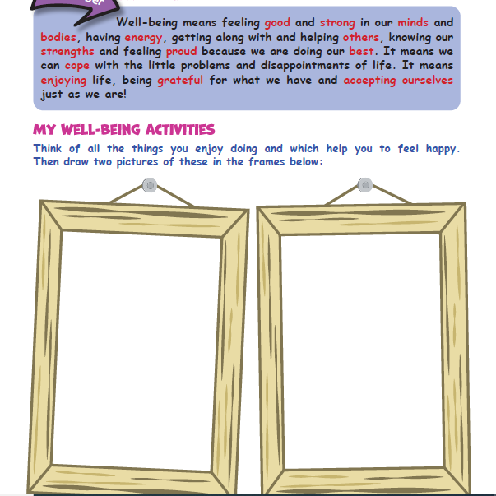  If you can, listen to calming music while you do these activities everyday to help you relax.
Art | Theme: Group Picture!  Draw/paint/colour/decorate/print the word beside your name. Make sure it is big enough and bright enough to be seen. Then take a picture holding up your word. I will then join all the pictures together to create a message from our class. Here is an example of what your picture may look like:  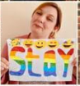  - Ben - Apart!  - Erin - 5th Class  - Samanvi - Are  - Aaron - We  - Seán - In  - Chloe - Though  - Jacob - Connected  - Jada - Show  - Luke - Even  - Catalina - Stay  - Eoin - Still  - Mel Dylan - Can  - Laurentiu - We  - Ufuoma - That  - Amy - Wanted  - Faye - You  - Gedas - We  - Kaitlin - Back  - Ciara - Scoil Mhuire  - Cian L - Be  - Josh - To  - Ailbhe - Ms. Cleary’s  - Cian O’ H - Wait  - Sarah - Can’t  - Marvellous - We  - Maksim - To  - Toluwani - From  - Evelyn - Hello  Have fun! I cannot wait until we see the finished picture! I jumbled up the sentences……Can you guess what the picture will read?
Maths | Planet Maths: Pg. 157 –Topic: Number Sentences  To Revise:  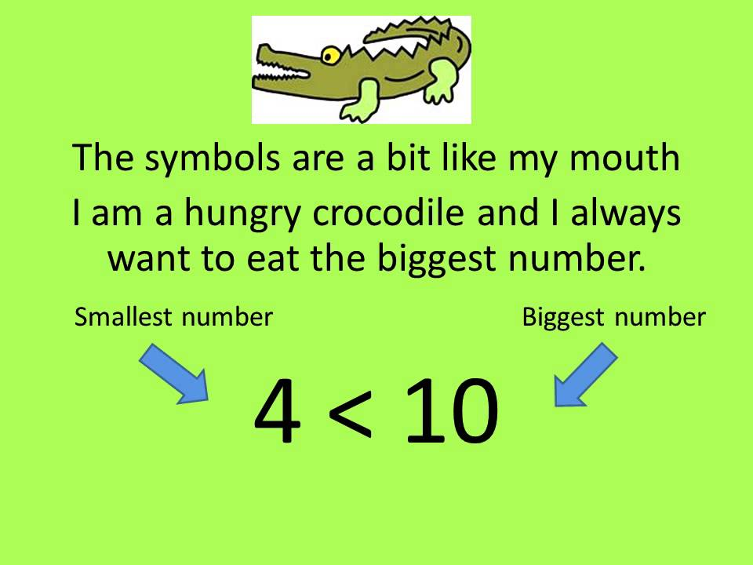  To Learn:  - Answer Orally: Ex. C 1-4  - Write the answers to: Ex. D (1-3) and E (1 +2) into your copy. Write full number sentences not just symbols.  - Tables Champion: Monday  - Mental Maths: Monday
Religion | - Read: Theme 8 Lesson 4 pg. 95 & 96  - Answer the questions orally.  Login details are as follows:  Grow in Love: www.growinlove.ie  Email: trial@growinlove.ie  Password: growinlove  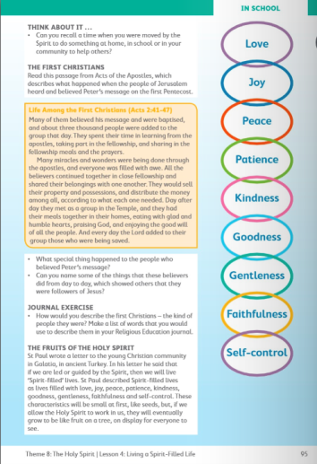  Visit: Grow in Love online with the help of a parent (only of you can) and under 5th class, Theme 8 Lesson 4, you will have access to the songs for the lesson this week, along with other resources.
Gaeilge | Téama: An Aimsir  Use folens online.ie to access the online resources. Use the word document on the school website to view the pages from the book.  - Éist leis an cómhrá “Tom Crean” (Listen to the conversation about favourite seasons being read aloud. Listen to it a second time an say the words with the reader.) Folens: Abair liom 5: Resources: Cómhrá 16  - Léigh an cómhrá D lch. 116 (Now practise reading it out loud by yourself)  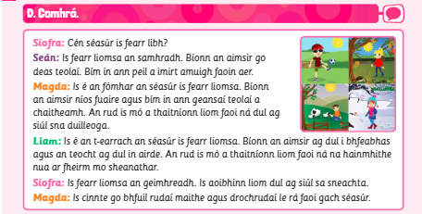  - Scríóbh 3 abairtí faoi “An séasúr is fear liom” (Write 3 sentences about your favourite season. Use the cómhrá to help you.  You can create a Folens account (with the help of a parent) to check the pronunciations of the words. Details on our class page.
Geography | Topic: Clouds  This week is all about clouds – If you wanted to do a project instead of answering the chapter questions that would be great! Some children have told me that they prefer doing the projects and I have been putting them on the school website!  Have you ever looked closely at the clouds above? Have you noticed that there are different types? What do you think they are made of?  - Read about the 3 different types of clouds on page 42 of your book.  - Look at the PowerPoint about clouds. See if you can remember the new information in the quiz at the end.  - Watch this short video about clouds https://www.youtube.com/watch?v=QAqeFSa60TE  - On a piece of paper or in your copy, make a chart similar to the one on page 43 so that you can keep a cloud watch diary for the week. Fill in the information for Monday  - Draw a little picture of each of the 3 most common cloud types on page 42 and label them.  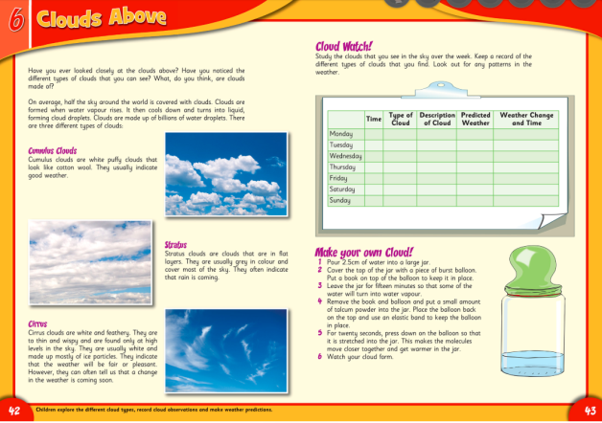

Tuesday
English | Reading:  - My Read at home: pg. 95 + answer questions orally  - Up and Running: wordlist  - Up and Running: pg. 181, 182, 183 of the story “Women and children first”.  - DEAR: 10 mins  You can access Up & R here: https://my.cjfallon.ie/preview/student/2694  Writing:  - My Spelling Workbook: Unit 15, LSCWC x4 spellings  - My Spelling Workbook: Exercise 5  - Grammar: Up & Running, pg. 187 Ex. F Abbreviations into your copy/word doc.
P.E  Mindfulness | Do 15 minutes of any exercise of your choice  Complete Page 2 of your Wellbeing Work Pack.  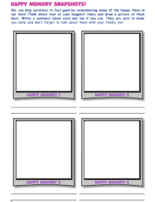
Maths | Planet Maths: Pg. 158 – Number Sentences  To Learn:  - Answer Orally: Ex. A (1)  - Write the answers to: Ex. A (2) and B into your copy  - Write 3 number sentences and 3 equations for exercise C  - Tables Champion: Tuesday  - Mental Maths: Tuesday
Religion | - Read this page about Sister Stanislaus Kennedy and Willie Bermingham and learn the “For Memorisation” section.  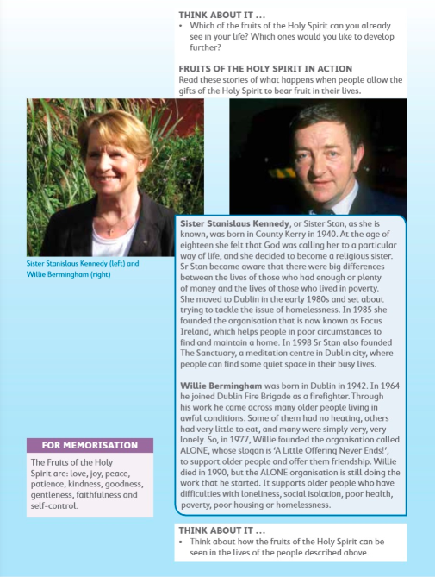
Gaeilge | - Léigh an cómhrá D arís ar lch. 116  - Freagair ceacht E (1-4) “Cén séasúr is fearr leat” lch. 116 (Answer 1-4 in your copy.  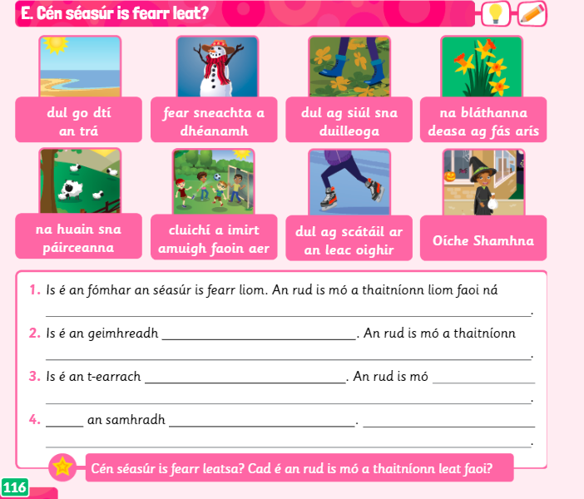
Music | - Listen to this famous piece of music https://www.youtube.com/watch?v=XCBDlC0N8Rc  - What does it make you think of and how does it make you feel?  - Name all of the instruments you can hear (orally)  - Draw an image to represent what you see in your head/ what you think about when you listen to this piece of music.
Science | Topic: The Ear  You can do a project on the ear if you would like instead of the questions each day!  - What do you know about the ear?  - Look at the power point on ‘The Ear’  - Read Chapter 4 in Window on the Word Science, The Ear.  - Choose one of the investigations to complete with the help of a family member.  (Don’t forget to fill in Tuesday’s cloud diary)  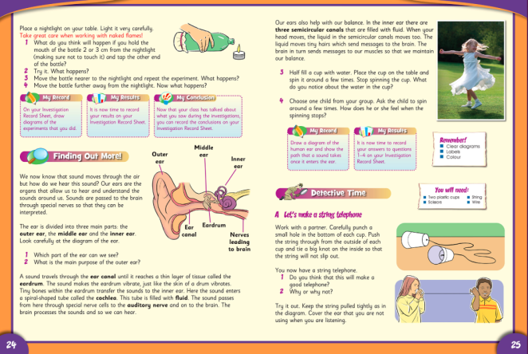

Wednesday
English | Reading:  - My Read at home: pg. 96  - Up and Running: wordlist  - Up and Running: Read pgs. 184, 185 “Women and children first.  - DEAR: 10 mins  You can access Up & R here: https://my.cjfallon.ie/preview/student/2694  Writing:  - Up & Running: Answer the questions in Quest + Query, Ex. D pg. 186  - My Spelling Workbook: Unit 15, LSCWC x4 spellings (2 revision)  - My Spelling Workbook: Exercise 6
P.E  Mindfulness | Do 15 minutes of any exercise of your choice  Complete page 3 of your wellbeing work pack.  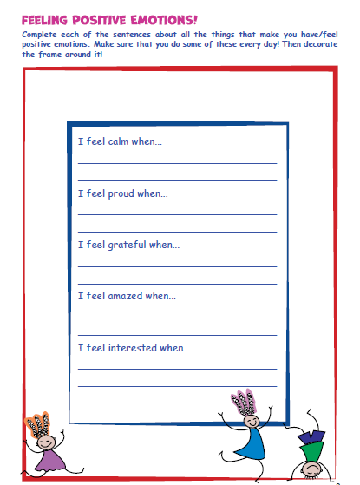
Maths | Planet Maths: Pg. 159 – Number Sentences  - Sing your counting songs – you could make your own counting stick and ask somebody in your house to test your skip counting.  - Answer Orally: Ex. A (1) and write one word sentence  - Write the answers to: Ex. B (1 - 4) and C (1 - 5) into your copy. (You will have to write the sentence using a frame, or an empty box, and then fill in the frame with the correct answer)  - Tables Champion: Wednesday  - Mental Maths: Wednesday
Religion | - Read this “At Home” page and chat about it with your family. Say the prayer together.  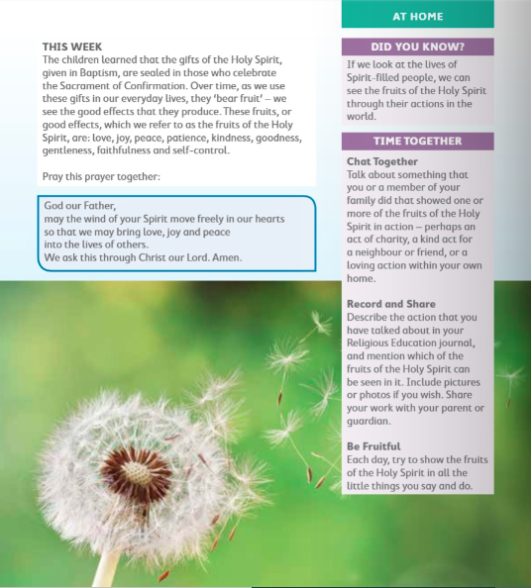
Gaeilge | - Gramadach H: ‘An-’ agus ‘Ró’ lch. 113 (complete the grammar activity H (1-5) pg. 113.  An- ____ = very ____ e.g. an-fuar = very cold.  Ró- ____ = too _____ e.g. ró-fhuar = too cold.  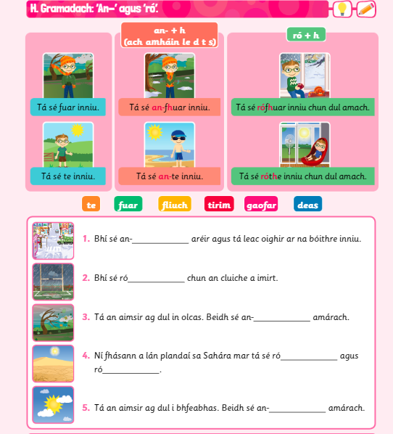
Geography | - Watch this second video about clouds https://www.youtube.com/watch?v=CezO52F_S_g  - Read the Quick Questions about clouds on pg. 44  - Answer questions 1-5 in question time pg. 46 in your copy.  - Don’t forget to fill in Wednesday’s cloud diary.  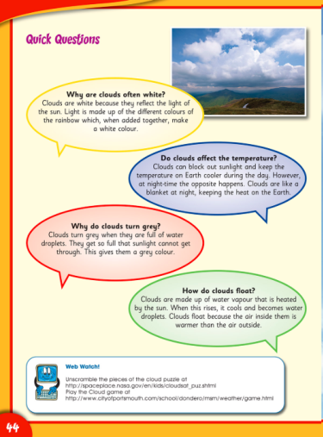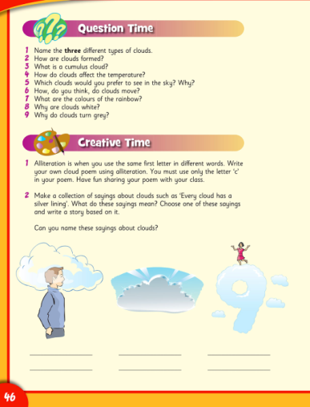

Thursday
English | Reading:  - My Read at home: pg. 97  - Up and Running: wordlist  - Look at the Persuasive Writing Example Poster Page again. Use it as a guide.  - DEAR: 10 mins  Writing:  - Should violent video games be banned? Use this worksheet to write a persuasive piece of writing on this topic. If you have a printer you can write on the page, if not you can copy the headings and write it into your copy. (Remember to use the word mat from last week to help you)  - My Spelling Workbook: Unit 15, LSCWC x4 spellings (revision words)  - My Spelling Workbook: Exercise 7
P.E  Mindfulness | Do 15 minutes of any exercise of your choice  Complete page 4 of your wellbeing work pack.  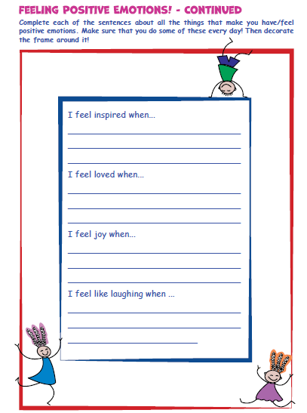
Maths | Planet Maths: Pg. 160 – Number Sentences  - Write the answers to: Ex. A (1), B (1 + 2), C (1-3) into your copy. Write out full equations.  *Remember for question C to convert any decimals to fractions first.  *Don’t forget the rule for getting a fraction of a number: Divide by the bottom then multiply by the top.  - Tables Champion: Thursday  - Mental Maths: Thursday
Religion | - Say “The Angelus” at 12:00  - Find a quiet moment to have a conversation with God, you could write a prayer, like you have been doing in your religion Journal.
Gaeilge | Briathra: An aimsir fháisteanach (Verbs: The Future Tense)  1. Scríóbh amach na briathra seo i do chóipleabhar. (Write out these verbs in your copy.) Pg. 118  Bí e.g. Beidh sé fuar = it will be cold  Clois e.g. Cloisfidh mé an nuacht anocht = I will hear the news tonight  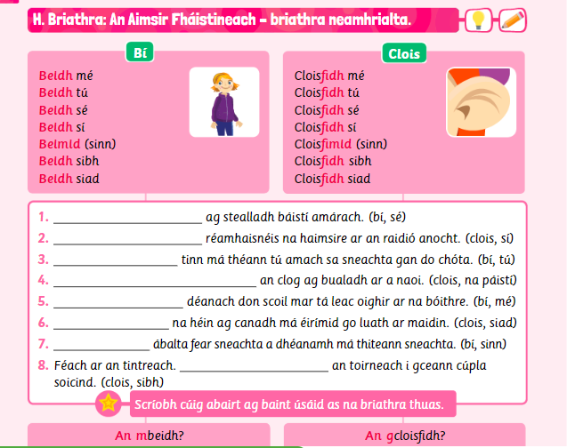  2. Scríobh na habairtí (1-5). (Write the sentences, putting in the correct verb) p.g 118
P.E | Don’t forget about Joe Wicks’ daily workout: Watch and join in with Joe Wicks’ at home workout  https://www.youtube.com/channel/UCAxW1XT0iEJo0TYlRfn6rYQ
Science | Topic: The Eye  - Look at the diagram of a human ear  - Now draw and label your own diagram of the human ear.  (Don’t forget to fill in Thursdays cloud diary)

Friday
English | Reading:  - My Read at home: pg. 98  - Up and Running: wordlist  - DEAR: 10 mins  Writing:  - MRAH: Answer questions in copy pg.98  - My Spelling Workbook: Unit 15, LSCWC x4 (revision words)  - My Spelling Workbook: Exercise 8
P.E  Mindfulness | Do 15 minutes of any exercise of your choice  Complete page 5 of your wellbeing work pack.  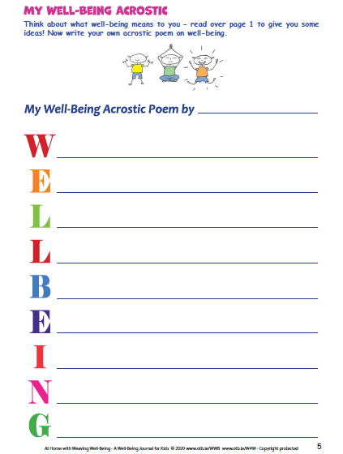
Maths | Planet Maths: Pg. 161 – Number Sentences  - Counting, skip counting (10 mins)  - Write the answers to: Ex. B (1 + 4) and C (1-4) into your copy  - Mental Maths: Friday Test
Gaeilge | 1. Léigh an dán gearr “An Sneachta” lch. 120 (Read the short poem about the snow)  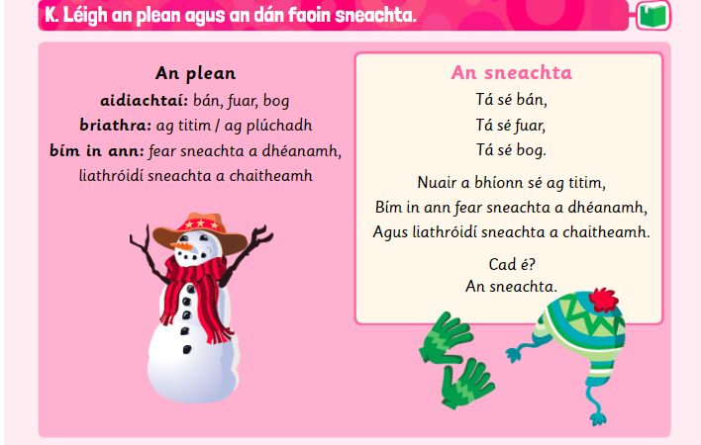  2. Líon na bearnaí chun dán a scríobh faoin ngaoth (Using the plan on the left, and following the same format as the poem about the snow, complete the poem about the wind. Write in copy.  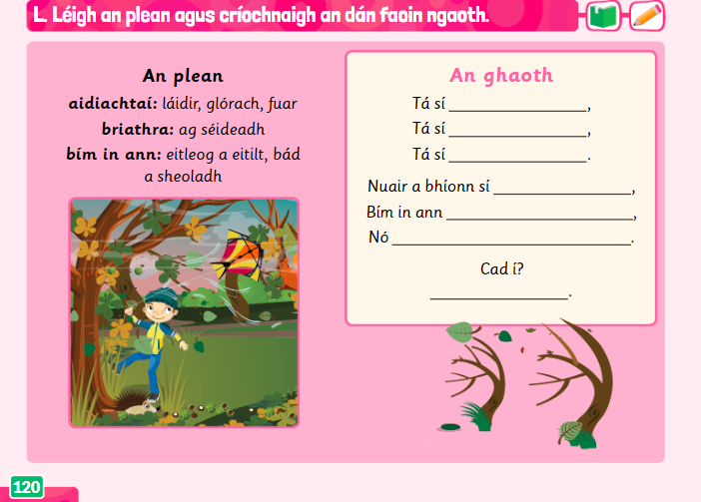
Geography | - Read the poem Clouds on page 44 and answer the questions orally.  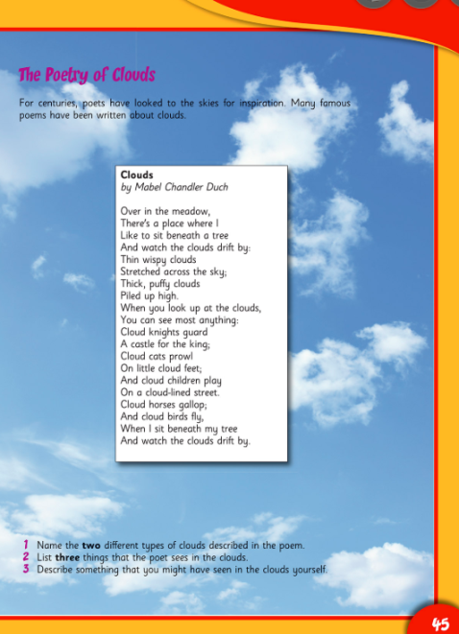  2. Write a short poem about clouds using alliteration. All of your words must begin with the letter C. You may use small words like a, the, in, are etc. but most of your words should start with ‘c’.  - Below is an example of an alliteration poem using the letter ‘T’  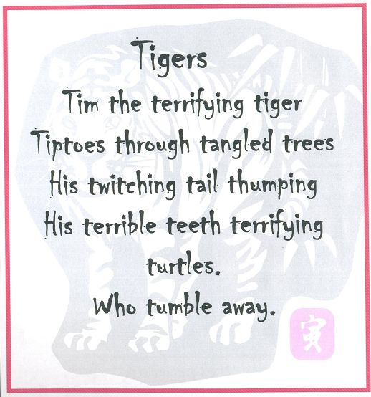  3. Fill in your cloud diary for Friday. Do you notice any patterns in the weather from the week? Were your predictions correct? What was the most common type of cloud you observed throughout the week?

