As the school was due to be closed Monday and Tuesday for the
Bank Holiday Weekend, I have only set work for Wednesday – Friday.

It was due to be Intercultural Day this week. If the children would like they can research a country of their choice and complete a short
project on that country. This can take the form of Powerpoints,
posters, drawings, videos etc. They are encouraged to team up with siblings to complete their projects also.

I have assigned the children the task of researching Australia this week. There will be an activity based on Australia each day this week. If they would prefer to research their own country instead that is perfectly fine.
If you have any questions or concerns please don’t hesitate to email me.

Thanks
Mr Kennedy
p.kennedy@scoilmhuireleixlip.com
Wednesday 3rd June
English
- Write your news from the weekend and draw a picture.
- ‘Jasper Saves the Day’ reading p 7 and 8
- Spelling workbook: Unit 8 exercise 8
- Spelling list 29: Put one word from today’s spellings into a sentence
Maths
- Mental Maths: Week 33 Monday and Tuesday and the problems
- Tables: -10
- Planet maths: P.150
Gaeilge: Siopadoireacht- Ceacht 7
- Click the yellow speech bubble and listen to comhra
- Complete Bua na cainte p82
S.E.S.E: Australia
- If we were in school this week, we would have been celebrating Intercultural
- Day on Friday. The country I would have chosen for us to learn about is Australia. I
- have uploaded a short video onto our webpage about Australia. Watch the video and write 5 facts.
Art: Aborigines come from Australia. They used patterns to tell stories about their life, land and animals. They use colours you find in nature such as black, white, red, brown and yellow.
Try some Aboriginal art at home. If you have a cotton bud at home, dip it in paint to create the dots. If not, use pencils or crayons.
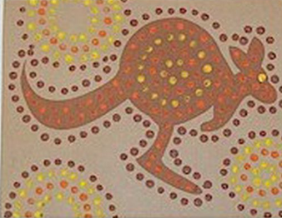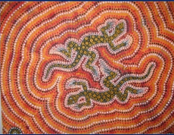
Thursday 4th June
English
- Spelling list 29 Put one word from today’s spelling list into a sentence.
- Spelling workbook: Unit 8 exercise 9
- ‘Jasper Saves the Day’ read pages 9 and 10
Maths
- Mental Maths: Week 33 Wednesday and Thursday and the problems.
- Tables: -9
- Subtraction: These can be done in your maths copy
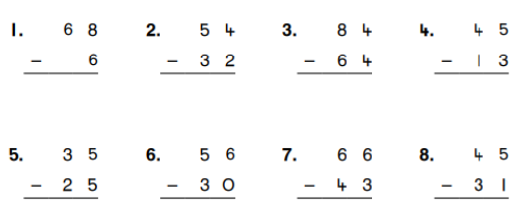

Gaeilge:
- Cad a cheannaigh tú? Cheannaigh mé......
This can be answered into your Gaeilge copy.
SESE: Complete the following worksheet orally.
Part C: add the 3 facts about Kangaroos to the facts you wrote yesterday.
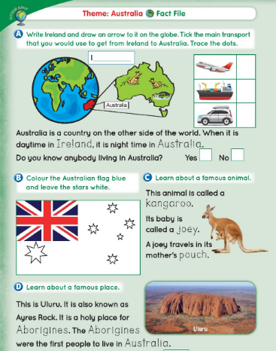
Friday 5th June

English:
- Spelling workbook: Unit 8 exercise 10
- Spelling test: spelling list 29
- ‘Jasper Saves the Day’ pages 10,11,12
Maths
- Mental Maths: Friday Review
- Table test
17-10= 13-10= 11-10= 10-10= 15-10=
19-10= 12-10= 16-10= 21-10= 22-10=
14-10= 20-10= 18-10=
Gaeilge: Tarraing rudaí isteach sa tralaí agus scríobh ‘Tá..... sa tralaí’.
Draw a trolley in your Gaeilge copy and draw different items into it. Write the sentence ‘Tá... sa tralaí’ Use the vocabulary on page 77 to help you.
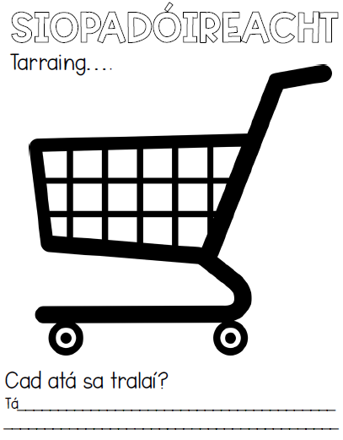
SESE: Australia
Watch the video on the ‘Great Barrier Reef’ on the class webpage. Draw 5 animals or plants you might find there. Use the worksheet below to help you.
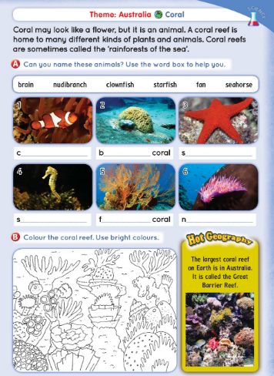
PE: Complete 30 minutes of exercise.
Well done on all your hard work this week.

