Monday May 25th 2020
3rd Class Ms Hughes
For additional support see https://padlet.com/thirdclassmshughes/7nelhuv6lglw4ti6
English (My Read at Home and Get Set are available online see webpage)
- My Spelling Workbook pg 64 Unit 16
Today’s spellings: parties-bullies (LCWC) Write spelling 3 times.
Write 4 sentences with each spelling word.
Answer Q5 Adverbs pg 64 My Spelling Workbook
Answer Q6 Proofreading pg 64 My Spelling Workbook
- Get Set –Read pages pgs 236-237 Famous Irish Landmarks
- Answer QA 1 orally. Answer QB1-5 What have you learned?
- My Read at home- Read the next page and answer questions orally.
- Library Book- Read your library book or listen to a story on www.storylineonline.net/library/ or Elevenses with David Walliams
Maths
- Mental Maths Book- Week 33 pg 87 complete Monday
- Tables Champion- Week 32 pg 41 complete Monday
- Warm Up- Word Problem
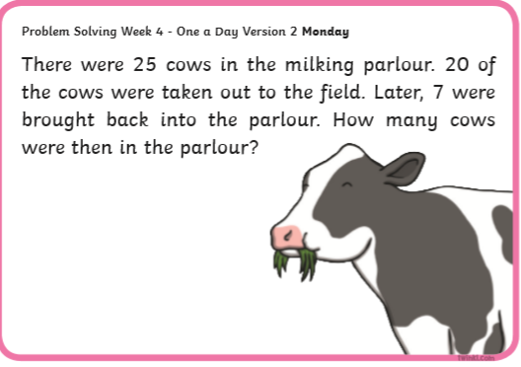
Planet Maths- Topic 26: Capacity pg 157 (capacity of a litre)
Estimate, compare, measure and record the capacity of a wide variety of objects using appropriate metric units (l, ml).
- Access Folens online and play the Capacity warm-up game.
https://content.folensonline.ie/programmes/PlanetMaths/PM3/resources/activitya/pm_3c_157/index.html
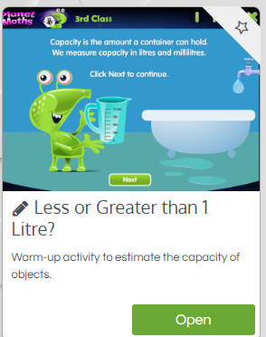

- In the book answer QB, C and D page 157.

Gaeilge
- Téama: Caitheamh Aimsire (Past Times)
- Litriú: giotar(guitar) + feadóg stáin (tin whistle). Write 3 times in copy like spellings.
- Draw a picture of a giotar agus feadóg stáin and label.
- Déan 10 as 10 https://rtejr.rte.ie/10at10/ as gaeilge

Religion
- Log in to ‘Grow in Love’ https://www.growinlove.ie/en/ and access the 3rd class materials.
- Email: trial@growinlove.ie Password: growinlove
- Select Third Class. Click into Theme 10: The Mass
Lesson 1: At Mass We Listen to the Word of God
- In resource section, listen to the song We Come To You Lord Jesus.
- Read page 79 and do the activity and chat about it.

Well-being
- Talk about Kind Mind. Complete the journal activity page.
- Choose a Well-being activity from padlet that you haven’t yet done
- Or try some Elephant Breathing

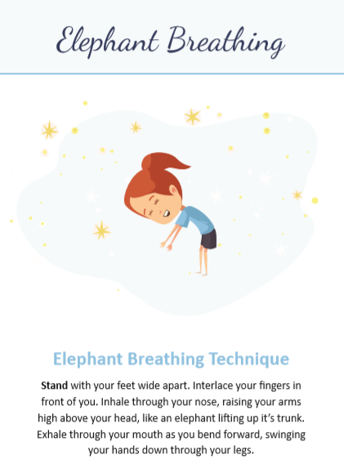

Pg 4 Breathe

