Monday June 8th 2020
3rd Class Ms Hughes
For additional support see https://padlet.com/thirdclassmshughes/7nelhuv6lglw4ti6
English (My Read at Home and Get Set are available online see webpage)
- My Spelling Workbook pg 66 Unit 17
Today’s spellings: uproar-boarder (LCWC) Write spelling 3 times.
Write 4 sentences with each spelling word.
Answer Q3 Crossword Down Clues pg 67 My Spelling Workbook
Answer Q4 Missing Words pg 67 My Spelling Workbook
- Work on Intercultural project if not yet completed
- My Read at home- Read the next page & answer questions orally.
- Library Book- Read your library book or listen to a story on www.storylineonline.net/library/ or Elevenses with David Walliams
Maths
- Mental Maths Book- Week 35 pg 89 complete Monday
- Tables Champion- Check back on any week not completed
- Warm Up- Word Problem:
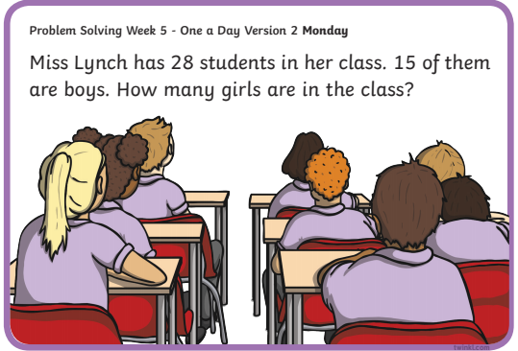
Planet Maths- Topic 27: Time 2 pg 162 (am/pm)
Consolidate and develop further a sense of passing time.
- Access Folens online and play warm-up activity for am and pm.
https://content.folensonline.ie/programmes/PlanetMaths/PM3/resources/activitya/pm_3c_162/index.html
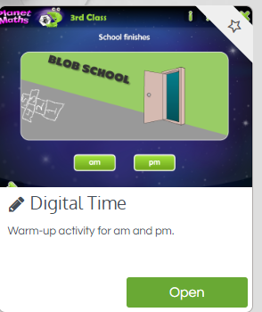

- In the book answer QB (a-h) and C 1-7 page 162.

Gaeilge
- Téama: Caitheamh Aimsire (Past Times)
- Déan 10 as 10 https://rtejr.rte.ie/10at10/ as gaeilge
- Abair Liom lch 158 Léigh an scéal agus freagair na ceisteanna
- Listen to the scéal from last week on padlet. This scéal is very similar to last week’s online version.
- Try and read it out loud yourself and answer the questions.
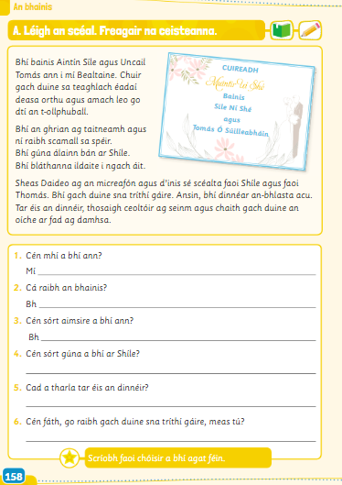

Religion
- Log in to ‘Grow in Love’ https://www.growinlove.ie/en/ and access the 3rd class materials.
- Email: trial@growinlove.ie Password: growinlove
- Select Third Class. Click into Seasonal/Additional Lesson 5: How We Have Grown in Love
- Listen to the song Grow in Love
- Look at pages 97 and 98 of your book and chat about it.

Art
- Enter the school Art Competition. The closing date has been extended to Wednesday 10th. See details below.
- Or choose a mandala to colour. These are available on the padlet.
