Monday June 15th 2020
3rd Class Ms Hughes
For additional support see https://padlet.com/thirdclassmshughes/7nelhuv6lglw4ti6
English (My Read at Home and Get Set are available online see webpage)
- My Spelling Workbook pg 70 Unit 18
Today’s spellings: barbecue-charcoal (LCWC) Write spelling 3 times.
Write 4 sentences with each spelling word.
Answer Q1 Small Words pg 70 My Spelling Workbook
Answer Q2 Letters into Words pg 70 My Spelling Workbook
- My Read at home- Read the next page & answer questions orally.
- Library Book- Read your library book or listen to a story on www.storylineonline.net/library/ or Elevenses with David Walliams
Maths
- Mental Maths Book- Week 36 pg 107-109 complete Monday
Complete Monday for the next week that you are on. Some people are on different weeks.
- Warm Up- Word Problem:
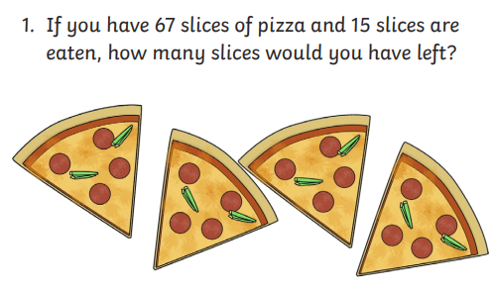
Planet Maths- Revision pg 167
- Revise addition and subtraction
- Answer QA1-8 pg 167
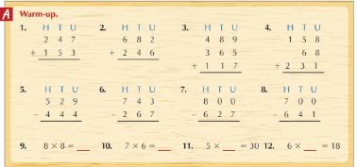
Gaeilge
- Téama: Ócáidí Speisialta (Special Occasions)
- Déan 10 as 10 https://rtejr.rte.ie/10at10/ as gaeilge
- Abair Liom lch 163 Dán- An Bronntanas is Fearr
- Listen to the dán being read on folens online https://content.folensonline.ie/programmes/AbairLiom/3rd_class/resources/Poem/AL_3C_ACT_POE_CH19_006/index.html
- Go on to padlet and listen to the translation
- Listen again online and follow along in your book.
Well-being
- Ways to deal with your worries. Read page 13.
- Complete page 14. Think of two things that are worrying you right now and write each one in a thought bubble.
- Then underneath write ways to deal with each worry.

