Monday 27th April
Before beginning work this week I ask you all to create an account on Folensonline.ie. This will give you access to the 1st class planet maths eBook which you will need to complete the maths work. Here are the instructions to create an account.
Active schools week
- This week we celebrate active schools week. Try to do one piece of exercise every day. There will be different challenges and exercises posted on the school website.
- Go Noodle Dance: This year our dance will be “Roar“,
https://app.gonoodle.com/activities/roar?s=Search&t=KIDSBOP
- Try and practise it every day. Get all the family involved.

English
1. Write your news from the weekend and draw a picture.
2. Read P. 37-38 the story ‘Sleep tight’.
3. Spelling Workbook: Unit 6 – exercise 1 and 2
4. Spelling list 24: put one word from the spelling list into a sentence

Maths
- Mental Maths: Monday p. 56 and the problem
- Tables: -5
- Complete the following sums into your copy. Remember to label your columns with T and U for tens and units.
Gaeilge
- Bua naCainte – An Teilifís Ceacht 4 - Click on the yellow speech bubble and select Comhrá. Press play and listen to the lesson.
- Complete Tasc Éisteachta 4.2
- Go to p. 68 of your book and carry out the reading page ‘Bí ag Léamh’.
The video game controller icon at the bottom will lead you games that you can play also.
Religion Theme 8: Lesson 2 - Sign up to ‘Grow in Love’ and access the 1st class materials. (Email address: trial@growinlove.ie Password: growinlove)
- Watch the video ‘Pentecost’ and talk about it with your family.
Active Schools week
“Marathon Monday”
- See how many laps of your garden you can do in the day!
- Challenge other members of your family.

Tuesday 28th April
English
- Read the story ‘Sleep tight’ P.39-40
- Spelling Workbook: Unit 6 exercise 3 and 4
- Spelling list 24: Put one word from today’s spellings into a sentence.
Maths
- Mental Maths:Tuesday p.56 and the problem
- Tables: -5
- Planet Maths: p.140
See attached word document explaining addition with renaming.

Gaeilge: Teílifís Cleacht 4
- An Teilifís Ceacht 4: Click on the yellow speech bubble and listen to the lesson again.
- Complete Tasc Éisteachta 4.2
- Complete P.69 in Bua na Cáínte
Religion: Theme 8 Lesson 2
- Complete p.46 in G.I.L workbook. (access ebook on grow in love website for this page)
SESE: The farm
1. Complete the reading below about the farm.
2. Answer the questions from the reading below into your free writing copies and then draw a picture.
- What animals do dairy farms have?
- What do people use crops to make?
- What do chickens eat?
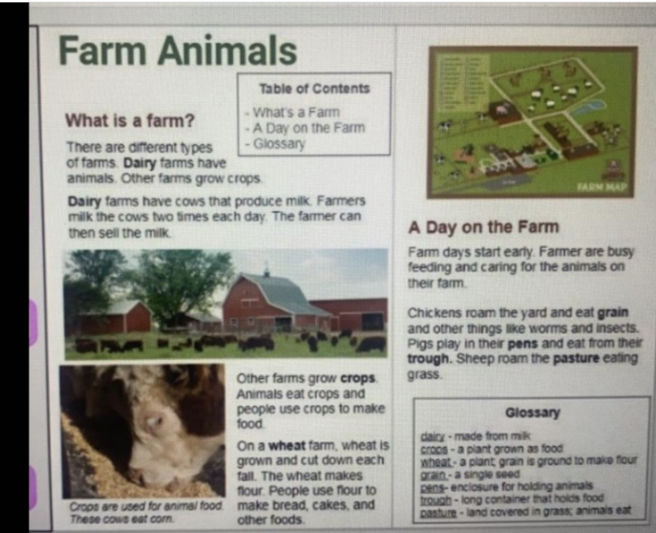

Active Schools week
“Target Tuesday”
- Using whatever equipment you have, set up a target challenge for your family in the garden.
- For example: How many footballs/tennis balls/toilet rolls can you get in to the bucket?

Wednesday 28th April
English
- Read ‘Sleep tight’ p.40
- Spelling workbook: Unit 6 exercise 5
- Spelling list 24: Put one word from today’s spellings into a sentence.
- Verbs: Discuss that a verb is doing or action work. Find examples of these types of words. Then watch powerpoint on verbs.

Maths
- Mental Maths: Wednesday and the problem p.56
- Tables: -5
- Complete the following sums in your copy or on a page.

Gaeilge: Cleacht 5- comhra 5.1
- Listen to the lesson.
- Play tasc éisteachta 5.1
- Listen to the ‘rann’ by clicking the green music icon.
Religion: Theme 8 Lesson 2
- Complete p.47 in G.I.L workbook
Art: Complete 2d animal cut out activity.
(Templates attached)
Active Schools week
- Be sure to get out for a walk with your family today.
- You could organise the pre walk warm up and cool down for the family.

Thursday 29th April
English
- What is this procedure for? Create the title for it and fill in the blanks with the sentences provided.
- Spelling list 24: Put one word from today’s spelling list into a sentence.

Maths
- Mental Maths: Thursday p.57 and the problem.
- Tables: -5
- Planet Maths: p.141
Part A: Make sure you label your ‘tens’ and ‘units’. Add units together first and then add tens. When this is done regroup your tens and units.
Counters may be used to help.

Gaeilge: Cleacht 5- comhra 5.2
- Listen to the lesson and play tasc éisteacht 5.2
- Listen to the ‘rann’ again by clicking the green music icon.
- Complete P.70 in Bua na cainnte.
Active Schools week
“Timing Thursday”
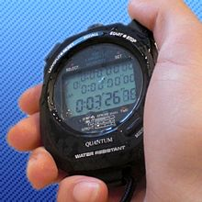
- Get the stopwatch ready: See how many of the following you can do in 1 minute?
- Jumping Jacks
- Frog Jumps
- Squats
- Lunges
- Scissors
- “Keepy uppies”
- Toe taps
- Challenge other members of your family!

Friday 29th
English:
- Spelling workbook: Unit 6 exercise 6 and 7
- Spelling test: spelling list 24
- Verbs worksheet: Fill in the correct verb in the space provided
]Read Oisin in Tír nÓg again and the retell the story in the correct order using pictures in the boxes below.

Oisin in Tír nÓg

1. | 2. | 3. | 4.
5. | 6. | 7. | 8.

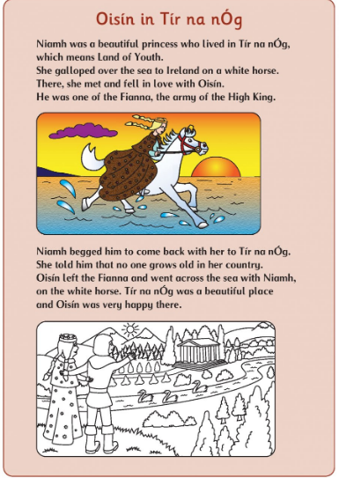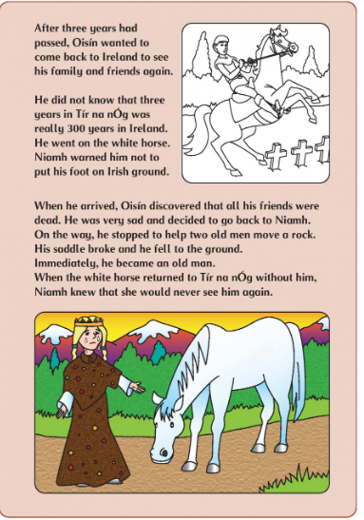

Maths
- Mental Maths: Friday Review p.57
- Table test
17-5= 6-5= 13-45
9-5= 10-5= 15-5=
7-5= 12-5= 16-5=
14-5= 8-5=
5-5= 11-5=
Gaeilge: Cleacht 6
- Listen to the lesson
- Complete the ‘Tasc Éisteachta’.

Active Schools week
“Fun Friday”
- Create an obstacle course for your family in the garden, using household and garden items (kitchen chairs, pots, laundry basket, dustbin, garden pots, buckets, a pillow case as a sack etc.)
- Who will be the fastest family member to complete it?
