Work for Monday 27th April
English :
- Wordlist for What a Box. Read and learn the first 3 words.
- show
- photographs
- my
What do these words mean? Find rhyming words. Find other words that start with the same sound. Put into a sentence. If able, try to write your sentence (use news copy).
- Our News: Write 3 or 4 sentences about what you’ve been doing over the past week. This week it’s Active School’s Week, so you could write about that. I’m giving an example of some sentences below. Feel free to copy them in your news copy.
Today is Monday.
It is Active Schools Week.
I am going to do lots of exercise this week.
My favourite sport is ____.
- Handwriting: Capital Letter K– see worksheet below. Like last week, if you have a printer you can print the sheet off. Otherwise, you can write it on a sheet or in a copy. The wording we use is ‘Start at the top, long line down. Lift your pencil, back to the top, diagonal line in, diagonal line out’.
- Phonics: There are some nice cartoon type videos on YouTube based on phonics. There are called the Alphablocks. I have attached one video below – but any of the Alphablock videos are suitable. These videos are all around 20 minutes each or longer, so no pressure to do them but they can be a nice extra activity for the children if needed.
https://www.youtube.com/watch?v=vqtkjJTSZjw

Gaeilge :
Bua naCainte – Teilifís Ceacht 5
- Click on the yellow speech bubble. Press play and listen to the lesson. You can listen to this 2/3 times. Play through once or twice and the third time, pause between sentences and repeat.
- Practise the phrase ‘An ___ é/í?’ Sea/Ní hea. (meaning Is it ___? Yes/no)
- You can then click on the Gameboy and play some games.
- Complete the Bua na Cainte page attached below – Pg 43 Picture of a buachaill bó (cowboy)

Maths :
- Counting practise : count forwards and backwards to 20. Count in 2’s even numbers and odd numbers. What number comes before or after a number?
- Practise saying the days of the week, months of the year and seasons.
- Find 2D shapes around the house – square, rectangle, triangle, circle.
- Today and tomorrow we will be looking at the different ways we can make the number 10- I’ve attached a video of the way we do this in school. The children are very familiar with this process as we’ve already manipulated the number 2 to 9.
- Planet Maths Book: Page 93– How many ways can you get the number 10? Use 10 household items – crayons, lego bricks, spoons.
number 10 is:
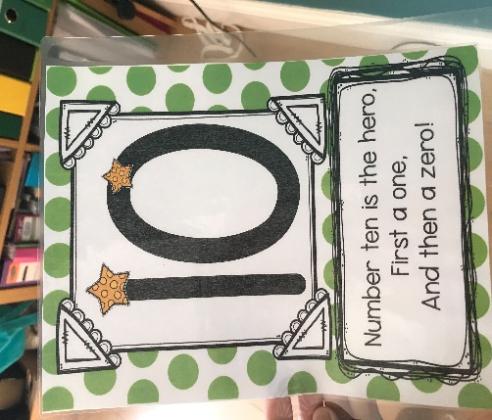

Religion :
This week we are on Grow in Love Theme 8: Lesson 1 : A place to Gather.
Watch the Video: ‘A House of Prayer’. There is also a nice song called ‘The Church’ that you can have a listen to.
(Go to Grow in Love webpage, use the sign in e-mail trial@growinlove.ie, password: growinlove).

SESE :
Last week for SESE, we looked at the theme of ‘Night and Day’. I have attached a PowerPoint sorting game. Once you open the PowerPoint, run it as a slideshow. The slides will show different activities that you do and you have to decide whether you do it in the day or the night and somethings you can pick ‘either’ if you can do it in the day and the night.

