Junior Infants daily work (8th- 12th of June)
Try your best to get through the work but don’t worry if you don’t get it all completed

Monday:
Irish:
Téama: Sa Bhaile
Ceacht 1:
- Listen to the comhrá 1.1 and 1.2 pausing at different places and repeating what is being said.
- Tasc éisteachta 1.1 and 1.2
- Draw a picture of Daidí Béar, Mamaí Béar, Babaí Béar and Cinnín Óir.

English:
- Wordbox 12a (1-5)
- Tricky words (1-25)
- Reading: Sentences 13 and 14: write and draw a picture of them.
- Phonics: “y”
- Writing: : Practice writing the letter “y” (Ready to Write page 60)
- Odd one out game

Maths:
- Use your cubes to count 1-10 forwards and backwards.
- Teddy Bear’s Picnic counting powerpoint (on our website page)
- Our topic this week is Money. What do you know about money? Why do we need it? What money have you seen? Where is money kept? What do you buy with your money?
- Play this maths game from the planet maths website: https://content.folensonline.ie/programmes/PlanetMaths/PMJI/resources/activities/pm_ji_122/index.html
- Planet maths page 122: Matching the coins to the correct piggy bank.

Religion:
Theme 9: We Give Thanks
Lesson 2: Thank you, God, for food
- Read the story below to your children “Monday Morning in Malawi”. There are accompanying pictures on the Grow in Love website.
- Chat about the story: Where does Mesi go before breakfast? I wonder…. Why doesn’t Mesi’s family always have enough food to eat? Do you remember a time when you were hungry? How did it feel? Do you remember a time when you shared food with someone?
- Listen to the Grace Before Meals song on the Grow in Love website and try and sing it before your lunch today.

Science: Light and Shade
- Observe and discuss objects that could provide light such as the sun, flashlights, lights and candles etc.
- Identify objects that can provide shade such as trees, buildings, parasols etc.
- Whatever day you decide to have the teddy bears picnic on, observe what happens to an ice pop in the sun vs. in the shade.
- Discuss observations – where did the ice pop melt the quickest?
- Below is a worksheet the children might like to do: They must circle the sources of light.

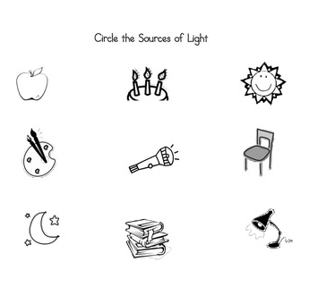

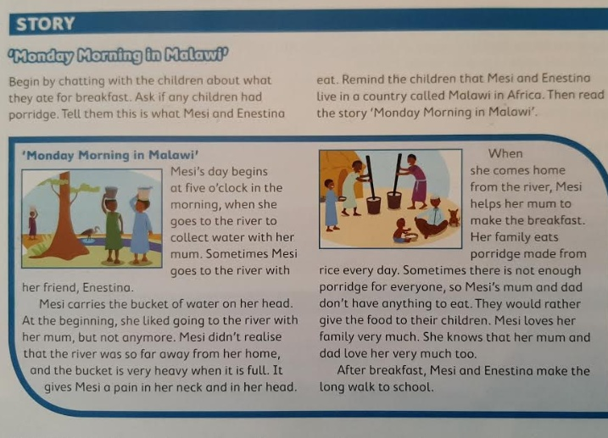

Tuesday:

Irish:
Ceacht 2:
- Listen to the rann “Mo Theach” and make up your own actions.
- Listen to the comhrá pausing at different places and repeating what is being said.
- Play cluiche Kim
- Tasc éisteachta 2.2
- Go outside and see if you can name all the parts of your house in Irish.

English:
- Wordbox 12a (1-5)
- Tricky words (1-25)
- Reading: Sentences 15 and 16: write and draw a picture of them.
- Phonics: “x”
- Writing: Practise writing the letter “x” (Ready to Write page 62)

Maths:
- Counting to 10 forwards and backwards, clapping and snapping every second number, sitting and standing for every second number etc.
- Teddy Bear’s Picnic colour by numbers page (on our website page)
- Pretend each cubes is 1c. Can you make 1c, 2c, 3c, 4c and 5c?
- Planet Maths page 123: How many of each coin can you find?

Religion:
- Read the below story “Mesi’s Evening” to the children. There are accompanying pictures on the Grow in Love website.
- Ask them questions afterwards: What did Mesi’s family do when they were finished their dinner? Are there any parts of Mesi’s evening that are the same as what you do when you come home from school? What is different? Do you like to eat rice? What might you like to eat with the rice? I wonder… what would you like about living with Mesi and her family? What would you find difficult?
- Grow in Love workbook page 50: Mesi’s meals

PE:
- Be sure to try and do your PE lesson with Joe Wicks this morning or try some yoga from Cosmic Kids.

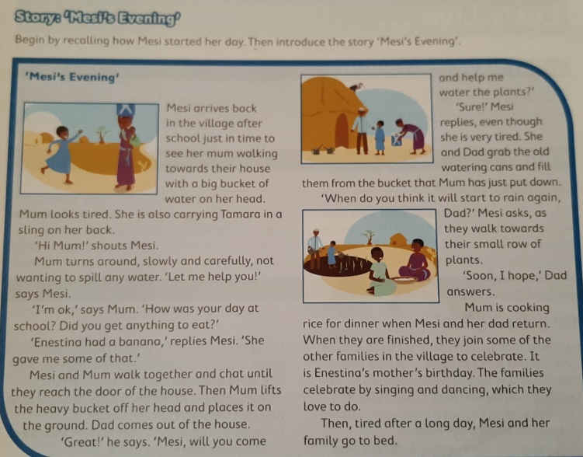

Wednesday:

Irish:
Ceacht 3:
- Listen to the rann “Simléar Oráiste” and make up your own actions.
- Listen to the comhrá 3.1 saying the numbers after Teidí.
- Comhrá 3.2: count with Teidí
- Tasc éisteachta
- Draw a picture of your house and count the windows in Irish when you have finished.

English:
- Wordbox 12a (1-10)
- Tricky words (1-25)
- Reading: New sentences 17 and 18: Write and draw a picture of them.
- Phonics: “ch”
- Writing: How many words with “ch” in them can you write?
- Can you write the sentence “It is a big bench.” by yourself? (Remember two finger spaces between words, froggy grip, capital letters and a full stop at the end of the sentence).
- Word Wizard page 75

Maths:
- Counting games
- Questions on the seasons (which season comes before Spring, after Summer etc.)
- Play this game from the planet maths website: https://content.folensonline.ie/programmes/PlanetMaths/PMJI/resources/activities/pm_ji_125/index.html
- Can you find five 1c coins in your house?
- Planet maths page 124: Colouring the correct amount of 1c coins in each piggy bank.

Religion:
- Try the spot the difference activity on the Grow in Love website. What are the differences between the inside of Mesi and Niamhs houses?
- Listen to the Grace After Meals song. Try and sing it after you have eaten your lunch today.

Aistear: The Ice-cream Parlour
Possible role play scenarios include:
- Serving a customer
- Paying / exchanging money
- Dealing with a spillage
- Enquiring about what flavours they have
- Ordering ice-cream from supplier

Construction:
- The children can build an ice-cream parlour or van with mobile, Lego or other small building materials.
- They need to include an area for customers to sit and enjoy ice-cream, bins for litter, etc.
- They could create litter awareness posters for the ice-cream parlour or to be displayed beside the ice-cream van.
- This could be further developed, asking the children to create benches for customers to sit and enjoy their ice-cream using large building materials. This could be integrated with the role play area.
- The children could be asked to create long and short benches, they could engage in measuring activities and comparing /estimating what items in the house their benches are similar in length to.
- Pupils could be asked to problem solve how to protect customers from the sun while sitting and enjoying their ice-cream.

Thursday:

Irish:
Ceacht 4:
- Listen to the rann “Dhá Éan Bheaga” and make up your own actions.
- Listen to the comhrá pausing at different parts and try repeating the lines.
- Cluiche Kim
- Tasc éisteachta 4.1 and 4.2
- Draw a picture of an ghrian, scamall, éan, eitleán in the sky and say the sentences:
Tá an ghrian sa spear. Tá scamall sa spear. Tá éan sa spear. Tá eitleán sa spear.

English:
- Wordbox 12a (1-10)
- Tricky words (1-25)
- Reading: Sentences 19 and 20: write and draw a picture of them.
- Phonics: “sh”
- Writing: How many words with “sh” in them can you write?
- How many words can you make with “sh” in them using your letters on card?
- Word Wizard page 76

Maths:
- Counting song
- Today I would like you to create your own shop. Items can cost 1c/2c/3c/4c/5c. Get another family member to play with you. Take turns at being the customer and the shopkeeper. I would love to see some pictures of your shop.
- Planet maths page 125

Religion:
- Watch the video “Enestina’s Family” on the Grow in Love website and chat about it.
- Talk about your favourite foods.
- Grow in Love workbook page 51

Art: Ice-cream Cones:
- Make a list with the children of all the different ice cream flavours they can think of in order to have them realise how many different colours ice cream comes in.
- Children sketch in pencil a cone with as many scoops of ice cream as they could fit on top.
- The children will then trace their lines in black crayon.
- Colour/paint the cone and ice cream scoops using what ever colours you like.
- Colour/paint the background in one solid colour. You make like to add sprinkles when you are finished

Friday:

Irish:
Ceacht 5:
- Listen to the 3 rann from this week.
- Listen to the comhrá, pausing after each sentence and try to repeat them.
- Cluiche Kim and Cluiche Cuimhne
- Tasc éisteachta 5.1
- Go outside to your garden and see how many of the sentences you can say:
Tá ________sa ghairdín. (bláthanna, crann, fear, éan, cat, madra)

English:
- Wordbox 12a (1-10)
- Tricky words (1-25)
- Reading: Sentences 21 and 22: write and draw a picture of them.
- Phonics: “th”(tongue comes out a little)
- How many words with “th” in them can you think of? (that, then, this, feather, weather, brother, sister, mother, father, with)
- Word Wizard page 78

Maths:
- Counting games
- Days of the week: Today is _______. Here is a lovely sing along video for the days of the week: https://www.youtube.com/watch?v=spi77By9-iA
- Set up your shop again today maybe selling different things. What can you buy from your shop if you only have 2c? What can you buy from your shop if you only have 3c?
- Planet Maths page 126

Religion:
- Listen to the song from the Grow in Love website: https://vimeo.com/141462231
- This week we are thankful to God for all the lovely food that we are lucky enough to have. Using the 5 fingers on your hand, list 5 other things you are thankful to God for this week.

PE:
- Be sure to do your PE with Joe Wicks today or try some dances from Go Noodle.
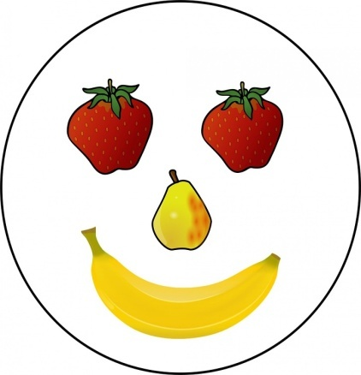
Well done on working so hard this week.
Have a lovely weekend and enjoy a well deserved rest!!

Ms O’ Grady

