Junior Infants daily work (20th- 24th of April)
Try your best to get through the work but don’t worry at all if you don’t get it all completed!
Monday:
Irish: The following is a link to download Bua na Cainte. The username and password is trial. The children love it in school so I thought it would be nice if they could listen to it at home.
https://www.dropbox.com/sh/2l9k7prhpldw0od/AADc4BRbSDaUY04h6Rp_ZAX9a/PC?dl=0&subfolder_nav_tracking=1
Téama: An Teilifís
Ceacht 1:
- Listen to the song Húrla, Harla, Hó and make up your own actions.
- Listen to the cómhra 1.1 and 1.2.
- Play cluiche kim, tasc éisteachta 1.1 and 1.2.
- Practice saying the line Tá _______ ar an teilifís. (sorcas, moncaí, tíogar, leon, cangarú)
English:
- Wordbox 8a (1-5)
- Tricky words (1-8)
- Reading: I have attached a document on our website page with lovely sentences for you to read. Read sentences 1 and 2 today and draw a picture of them.
- Phonics: We are going to revise a sound every day, we will be starting with “S” can you remember the song or the story?
- How many things can you see in the house and outside beginning with “S”
- Play eye spy with words beginning with “S”
- Writing: Practice writing the letter “S” (I have attached the letter formation sheet)
Maths:
- Planet math’s little book page 28
- Try some of the counting games we play in school:
- Count the claps (don’t go over 10)
- Teddy jumps (how many jumps did your teddy do?)
- Clap and snap (clap and snap every second number up to 10/tap your shoulders then your head etc.)
- Sound of a number (dropping objects in to a box, the children have to listen and guess how many you dropped)
- Show me (6 jumping jacks, 8 frog jumps, 2 hops etc.)
- Look at all the containers in the house that hold liquid (water bottle, orange juice carton, milk carton etc.) Try and find some empty ones that you could use for tomorrows lesson.
Religion:
- Here is the link again to download the Grow in Love resources (www.growinlove.ie use the email address: trial@growinlove.ie and the password: growinlove)
Theme 7: The Church
- Watch the “Vox pop”. Talk about places you like to pray to God.
- Listen to the song “The Church”.
SESE:
- Discuss the emergency services and what each of them do.
- Oral language poster: The Fire Station (I have attached a list of questions that you can ask your child about the fire station on the website).
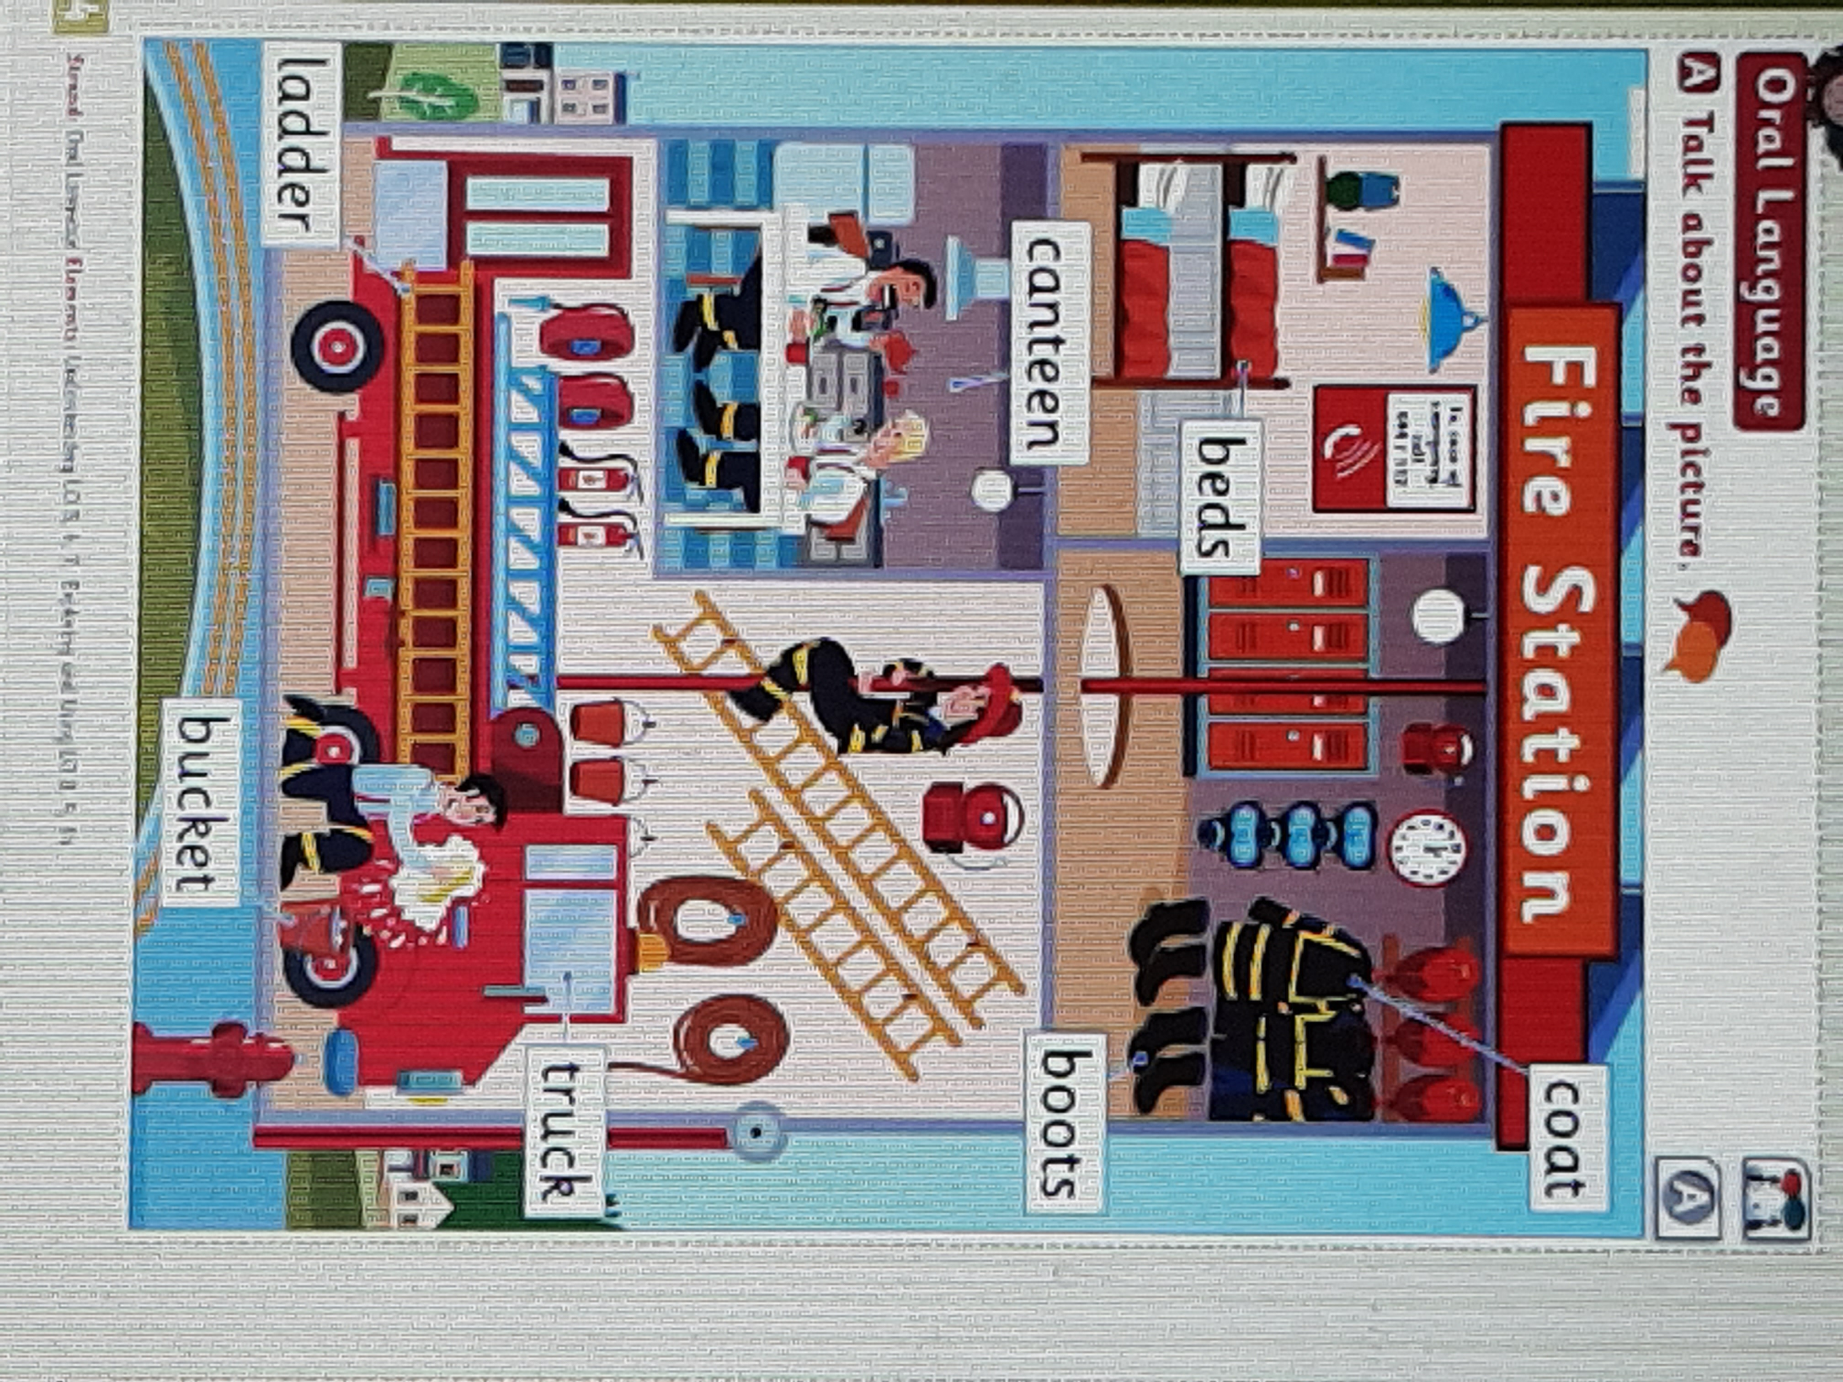

Tuesday:

Irish:
Ceacht 2:
- Listen to the song Húrla, Harla, Hó.
- Listen to cómhra 2.1 and 2.2.
- Play cluiche Kim and cluiche cuimhne.
- Try the tasc éisteachta.
- Play Simon Says (Deir O’ Grádaigh) with your family using the following actions: (ag canadh, ag damhsa, ag léim, ag rothaíocht, ag ithe, ag ól,ag rith, ag léamh, ag scríobh,ag gáire,ag súgradh, ag snámh)
English:
- Wordbox 8a (1-5)
- Tricky words (1-8)
- Reading: Sentences 3 and 4 and draw a picture of them.
- Phonics: “a” can you remember the song or the story?
- How many things can you see in the house and outside beginning with “a”
- Play eye spy with words beginning with “a”
- Writing: Practice writing the letter “a”
- Can you write a word that has “a” in it?
Maths:
- Planet math’s little book page 29
- Counting games
- Using some containers and materials such as a cup, a measuring jug, an egg cup etc. and water look at which containers hold more (for example which will hold more an egg cup or a bottle of water, which will hold more a yoghurt pot or a cup)
Religion:
- Watch the video “The Church – a place to pray”. Talk about what the girl is doing. Have you ever lit a candle in the church to pray for somebody? If you could visit the church today, who would you say a prayer for?
- Grow in love workbook page 42.
PE:
- Tuesday is our school PE day so be sure you do your PE lesson with Joe Wicks at 9am today.

Wednesday:
Irish:
Ceacht 3:
- Listen to the song Húrla, Harla, Hó.
- Listen to the cómhra.
- Play cluiche Kim and the tasc éisteachta.
- Draw your own picture of a Fearr Grinn and see if you can give a sentence in irish to describe him after.
English:
- Wordbox 8a (1-10)
- Tricky words (1-8)
- Reading: Sentences 5 and 6 and draw a picture of them.
- Phonics: “t” can you remember the song or the story?
- How many things can you see in the house and outside beginning with “t”
- Play eye spy with words beginning with “t”
- Writing: Practice writing the letter “t”
- Use your letters on card to make some words beginning with “t” and write them.
Maths:
- Planet math’s little book page 30
- Counting games
- Using the materials from yesterday today we are going to look at which holds less (for example which will hold less and egg cup or a pot of water, a cup or a milk carton).
- Have a look at this video: https://www.youtube.com/watch?v=12njHlMOdHo

Religion:
- Lots of people need our prayer during this time. Put on the quiet and still music and say a silent prayer for all the doctors, nurses, care workers and all the people who are working so hard to keep us all safe and well. Don’t forget to include your super parents for taking such good care of you and your wonderful Grandparents who are missing you so much.
- Why not try the art activity – prayer hands
Aistear:
Our Aistear theme for this month is the “Emergency services”, you could try and set this up in your house.
Possible role play scenarios include:
- Answering the phone at the fire station
- Firefighters having break / sleep and alarm sounds to get ready
- Fighting a fire

These scenarios can also be used for small world (they can use cars as emergency vehicles, use figurines/dolls for the emergency workers etc.)
Construction: Using small blocks such as Lego or something similar you could design a fire station. Ask them to consider all the areas required, such as: kitchen, dorm room, parking area for engines, locker room, etc.

Thursday:

Irish:
Ceacht 4:
- Listen to the song Tá Téidí sa Seomra Suí and make up your own actions.
- Listen to the cómhrá.
- Cluiche Kim, tasc éisteachta 4.1 and 4.2.
- Get your favourite teddy and put him sa chistin and say “tá teidí sa chistin, put him in the seomra leapa and say “tá teidí sa seomra leapa, put him in the seomra suí and say “tá teidí sa seomra suí” you can practice this a few times with different teddys if you like.

English:
- Wordbox 8a (1-10)
- Tricky words (1-8)
- Reading: Sentences 7 and 8 and draw a picture of them.
- Phonics: “i” can you remember the song or the story?
- Can you think of some words beginning with “i” or that have “i” in the middle of the word.
- Writing: Practice writing the letter “i”
- Try and write the words: sit, pit, bit (what can we say about these words – they rhyme)

Maths:
- Planet math’s little book page 31
- Counting games
- Today the concept is how many? So how many egg cups will it take to fill this cup, how many cups will it take to fill the jug, how many yoghurt pots will it take to fill the juice carton etc. Get the children to guess first before they carry out the experiment.
Religion:
- Listen to the song “The Church”
- Grown in Love workbook page 43, try the chat together and pray together sections too.
Art:
- Thursdays are our art day in school, here is an activity connected with our Aistear theme that you could try:
- Fire Engines
Use cardboard boxes to create a fire engine
- Use Easter egg boxes, cereal boxes etc. to create the fire engine
- Paint the fire engine red and wait for it to dry
- Cut out and stick on black card rectangles for the windows and front bumper, with black circles for the wheels and orange ones for the headlights.
- Glue silver rectangles to each side to be the doors of the storage lockers
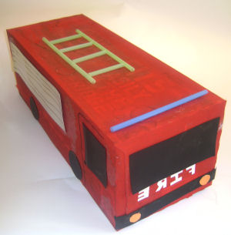

- You could also draw a picture of a fire engine or make one using junk art.
Friday:
Irish:
Ceacht 5:
- Listen to the song Tá feirm ag an bhfeirmeoir and make up your own actions.
- Listen to the comhrá.
- Play the cluiche meaitseála.
- Draw a picture of the bó, lao, caora, uan, muc, banbh and see if you can name them in Irish after.

English:
- Wordbox 8a (1-10)
- Tricky words (1-8)
- Reading: Sentences 9 and 10 and draw a picture of them.
- Phonics: “p” can you remember the song or the story?
- How many things can you see in the house and outside beginning with “p”
- Odd one out (give a list of 3 words e.g. sun, pig, paint-which is the odd one out? sun because the other 2 words begin with “p”
- Writing: Practice writing the letter “p”
- Try and write the sentence “A pink pig.” (don’t forget froggy grip, 2 finger spaces between words, capital letter at the start of a sentence and a full stop at the end).

Maths:
To access the Planet Maths online resources:
- Go to folensonline.ie and click Register
- Select Teacher, fill in the username, email address and password
- For Roll Number use the code: Prim20,
- Click Register, then you will be sent an email to activate your account.
- Planet math’s little book page 32
- Counting games
- Draw me some containers that are full and some containers that are empty.
- Have a look at the Planet Maths page 91, can you pick out all the empty things in each row?
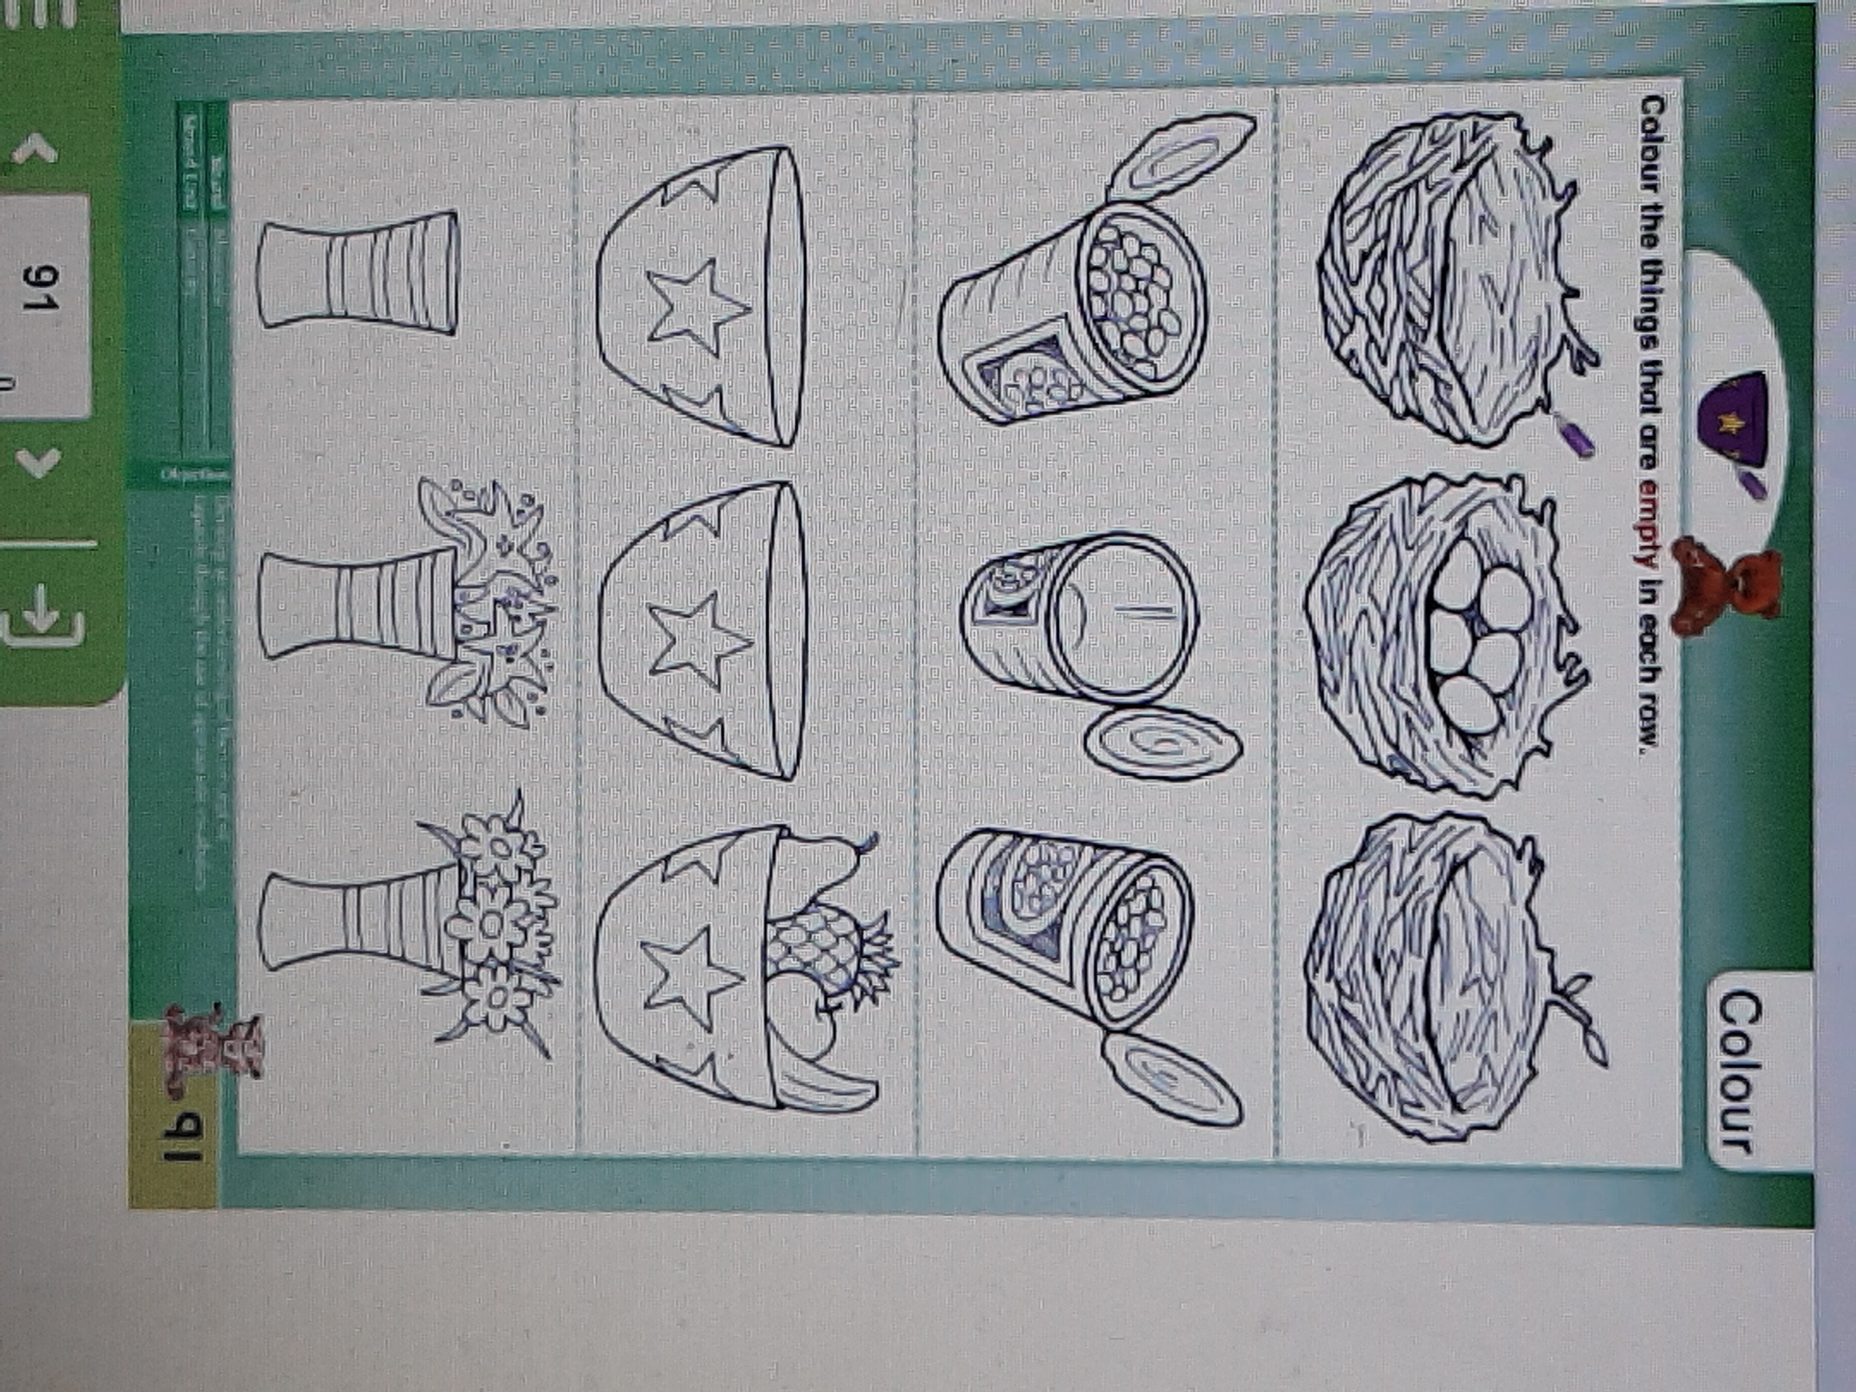
Religion:
- Using your hand, think of 5 things you are thankful for this week. Try and get other family members to do the same.

PE:
- Friday was our school PE day so be sure you do your PE lesson with Joe Wicks at 9am today.

Well done on working so hard this week. Have a lovely weekend and enjoy a well deserved rest!!

Ms O’ Grady



