Cuba pg.1
Cuba facts
Official name: republic of Cuba
Form of government: socialist republic
Capital: Havana
Population: 11,382,820
Official language: Spanish
Money: Peso
Area: 110,860 square kilometres
Flag:
Cuban flag
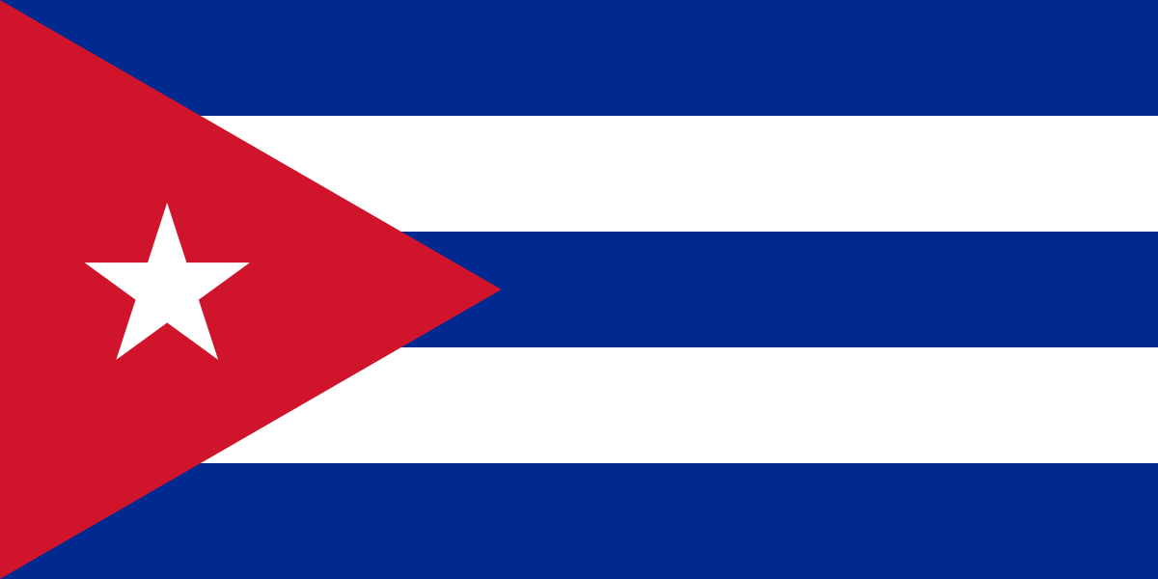
This Photo by Unknown Author is licensed under CC BY-SA

Cuba pg.2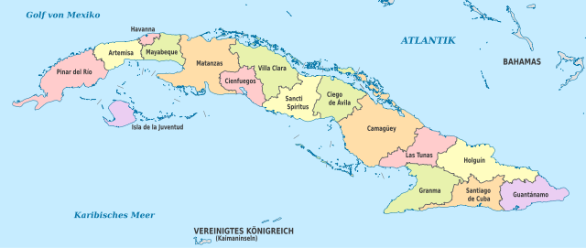
This Photo by Unknown Author is licensed under CC BY-SA
Map of Cuba

Cuba is famous for its music and the colour of different things like houses and furniture.

Here are some pictures
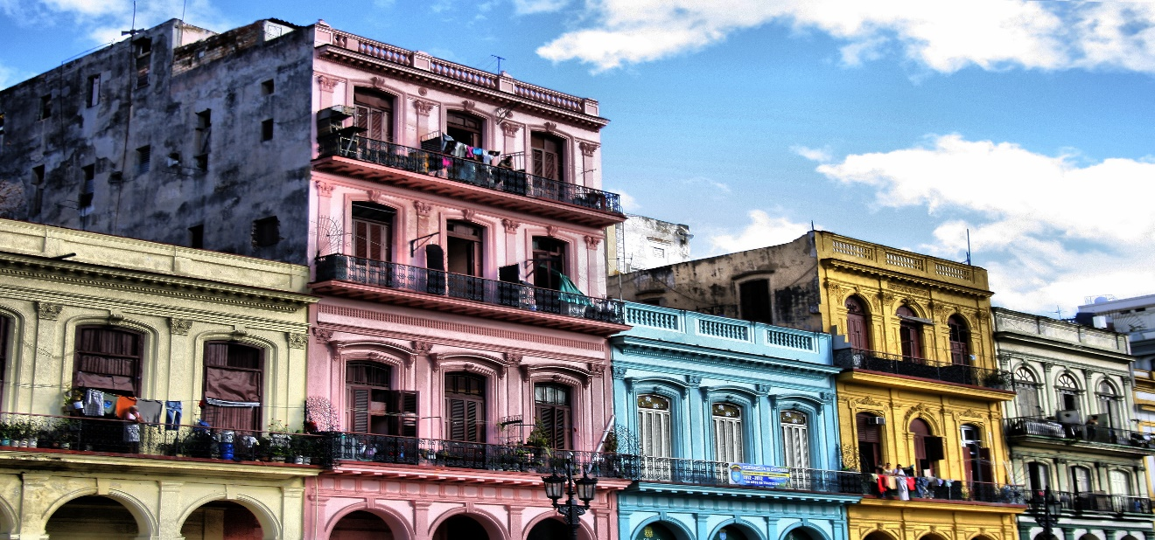
Pg.3
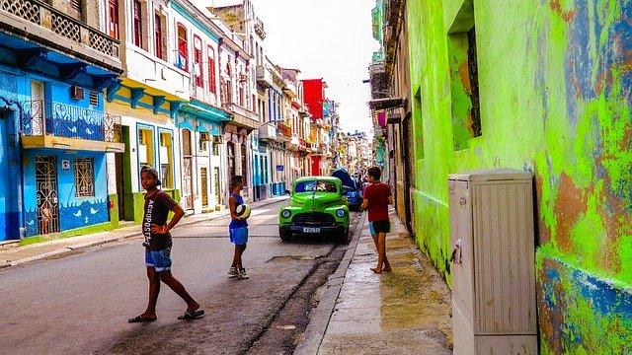

Cuba pg.4
Cuba is located in north America.
On the morning of August 31 , 2013 Nyad began her fifth bid to swim Havana, Cuba to Florida, a distance of about 110 miles
(180 km),accompanied by a 35-person support team, swimming without a shark cage but protected from jellyfish by a silicone mask, a full bodysuit, gloves and booties.

Little facts
- The smallest bird in the world lives in Cuba (the bee hummingbird).
- Baseball is Cuba most popular sport.
- The Cuban Trogon (Tocororo) is the country’s national animal.
- Cuba consists of more than 400 islands and cays.

Cuba pg.5

Havana
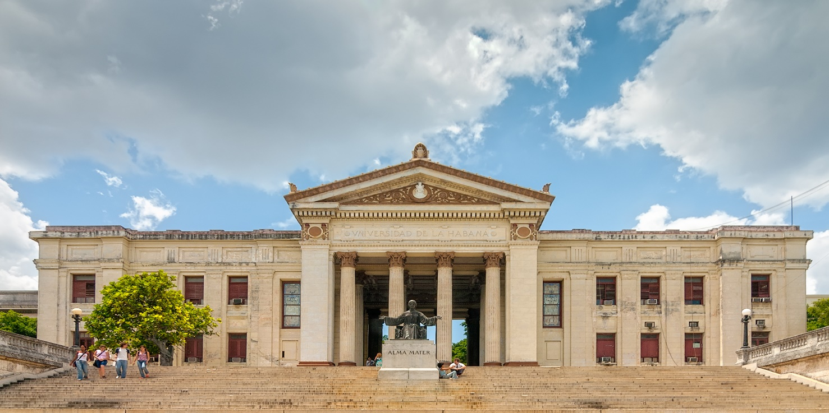
This Photo by Unknown Author is licensed under CC BY-SA

- Havana is the capital city of Cuba.

Cuba pg.6

