Friday May 15th 2020
3rd Class Ms Hughes
For additional support see https://padlet.com/thirdclassmshughes/7nelhuv6lglw4ti6
English (My Read at Home and Get Set are available online see webpage)
- My Spelling Workbook pg 61 Unit 15
Answer Q9 Tenses and Q10 Secret Code pg 61. Try Q11 Additional Activities if you like.
- Spelling Test- do your spelling test and get someone to correct it!
- Reading Comprehension- Read the text and answer the questions.
The text should be read at least 3 times. Student should be able to answer the Q’s independently.
- Read text
- Read questions
- Read text
- Answer questions
- Check questions

- Handwriting- complete pages 70+71
- My Read at home OR Library Book
Read your library book or listen to a story on www.storylineonline.net/library/ or Elevenses with David Walliams

Maths (Planet Maths available online see webpage)
- Mental Maths Book- Week 31 pg 85 complete Friday
- Tables Champion- Week 30 pg 39 complete Friday

- Warm Up- Word Problem
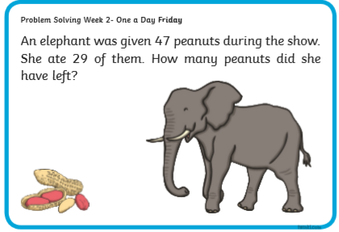

- Planet Maths-answer in Math copy if you have it or on any paper you have
- Revise what we were working on this week. Go back and work on something you found tricky this week.
Optional- Check Up! Pg 147 QB1-10 or more if you like!

Gaeilge
- Téama: Caitheamh Aimsire (Past Times)
- Litriú Bingo: Draw a grid with 6 boxes. Choose 6 of your litriú words this week and write one word in each box. Ask someone to call out a word from the 8 litriú words this week. Remember if you get bingo ‘Tá Bingo agam!’
Religion
- Log in to ‘Grow in Love’ https://www.growinlove.ie/en/ and access the 3rd class materials. Email: trial@growinlove.ie Password: growinlove
- Select Third Class. Click into Theme 9: Celtic Christianity
Lesson 1: Early Christian Ireland
- In the resource section, watch the video about St. Kevin and the Treehouse.

Art
- Draw your own Comic Strip about
The superhero that saved the world from COVID19
- Imagine what your superhero characters would look like?
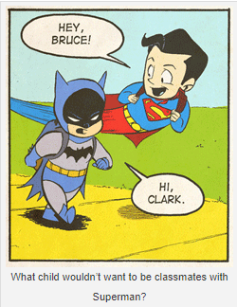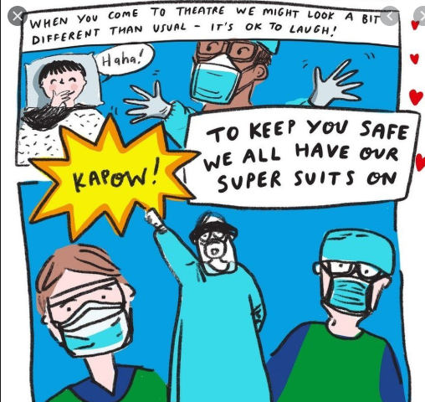
- In a comic strip each box in the strip continues the story being told like this
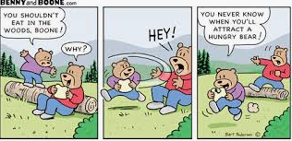
- Watch https://youtu.be/ufOXBuGhVWg for more details on how to draw a comic strip
Optional Choiceboard
- Choose a different activity to do each day.

Well done for all your hard work!
Have a great weekend!

