Friday June 12th 2020
3rd Class Ms Hughes
For additional support see https://padlet.com/thirdclassmshughes/7nelhuv6lglw4ti6
English (My Read at Home and Get Set are available online see webpage)
- My Spelling Workbook pg 68 Unit 17
Answer Q9 Word Search remaining 16 words pg 69 My Spelling Workbook
- Spelling Test- do your spelling test and get someone to correct it!
- Finish Intercultural project if not yet completed
- Reading Comprehension- Read the text and answer the questions.
The text should be read at least 3 times. Student should be able to answer the Q’s independently.
- Read text
- Read questions
- Read text
- Answer questions
- Check questions

- My Read at home OR Library Book
Read your library book or listen to a story on www.storylineonline.net/library/ or Elevenses with David Walliams

Maths (Planet Maths available online see webpage)
- Mental Maths Book- Week 33 pg 87 complete Friday

- Warm Up- Word Problem
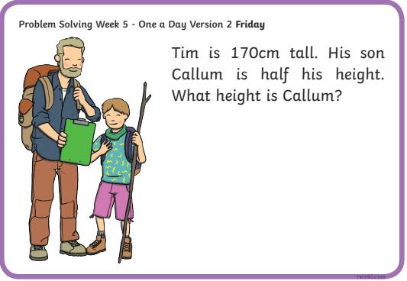

- Planet Maths- Topic 27: Time 2 pg 166
- Revise what we were working on this week. Go back and work on something you found tricky this week.
- Check Up! Pg 166 Answer QB+C and one other question of your choice or more if you like!

Gaeilge
- Téama: Caitheamh Aimsire (Past Times)
- Déan 10 as 10 https://rtejr.rte.ie/10at10/ as gaeilge
- Briathra: Aimsir Chaite (Past Tense Irregular Verbs)
- Have a look at and read the cards for bí, déan agus téigh
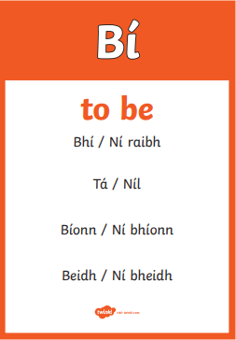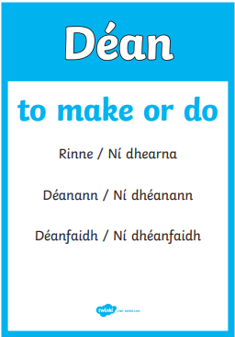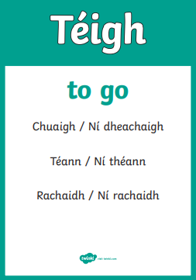
- Make up sentence for each Bhí…Rinne…Chuaigh…
- Déan Ceist F 1-6
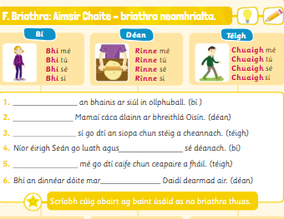
Music
- Take out your recorder and review songs we played with Mr. Gaskin by yourself (15mins approx.)
- Perform one of the songs for a member of your family.
Intercultural Project
- Finish country research project.

Optional Choiceboard
- Choose a different activity to do each day.

Well done for all your hard work!
Have a great weekend!

