France Project!

France Facts!
- The capital city of France is Paris.The population of France is 67,273,511.
- France is One of the Largest Country In the EU known as the hexagon.
- The French anthem is also called La Maresillaise.
- France is a word leader in launching space satellites.They are a high-flying economy.
- France is known for their food Known-as Baguettes,French Fries,Croissants,Crepes,Tarte Tatin.
- The French have some interesting Holidays.Bastille Day is a celebration of the French of the French Revolution on the 14th of July.

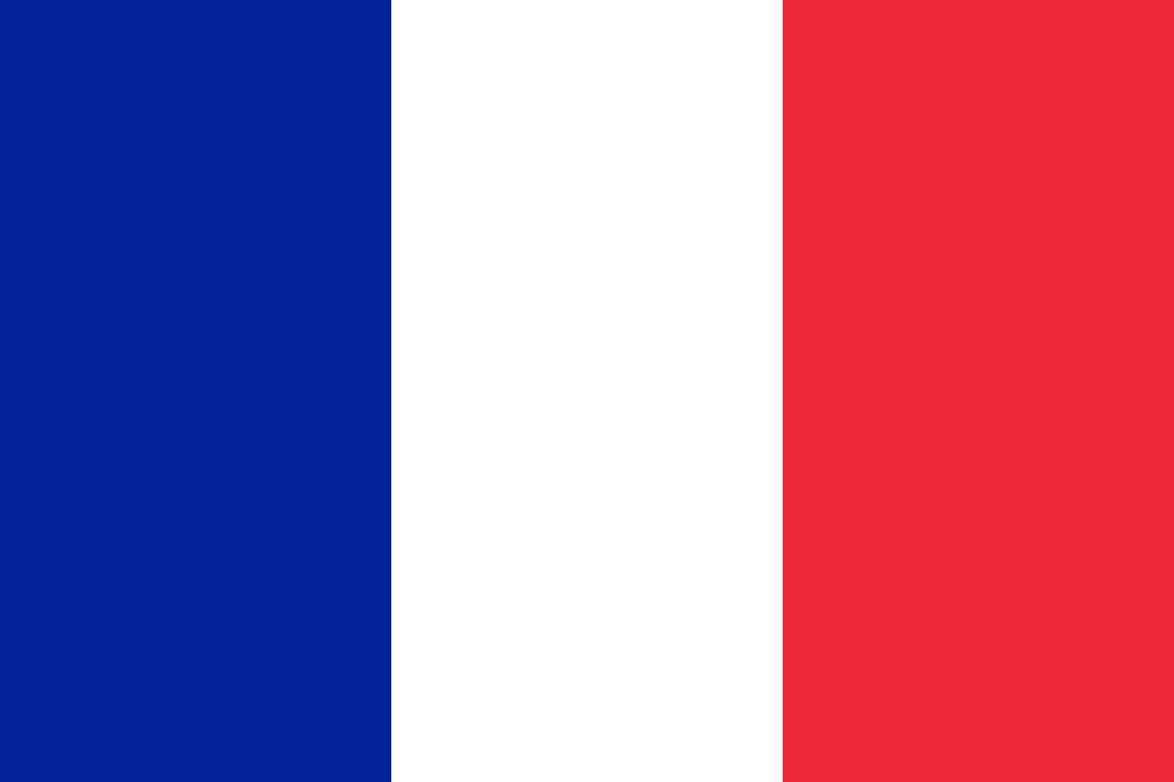
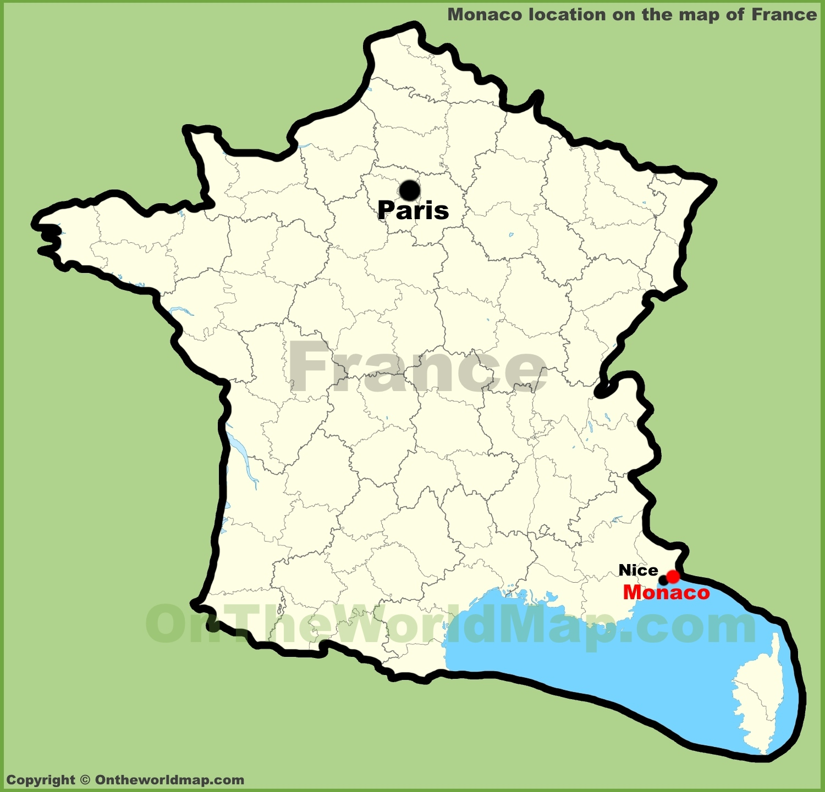

By Naomi Kengne

