Day Four
Week of June 22nd 2020
3rd Class Ms Hughes
For additional support see https://padlet.com/thirdclassmshughes/7nelhuv6lglw4ti6
English (My Read at Home and Get Set are available online see webpage)
- My Spelling Workbook pg 72 Unit 18
Today’s spellings: uniform-there (LCWC) Write spelling 3 times.
Write 4 sentences with each spelling word.
Answer Q9 Word Search remaining 16 words pg 73 My Spelling Workbook
Optional Q10 Additional Activities
- My Read at home- Read the next page and answer questions orally.
- Library Book- Read your library book or listen to a story on www.storylineonline.net/library/ or Elevenses with David Walliams

Maths (Planet Maths available online see webpage)
- Mental Maths Book- Week 38 pg 110-112 complete Thursday
Complete Thursday for the next week that you are on. Some people are on different weeks. Complete any remaining weeks during the holidays if you can.
- Warm Up- Word Problem
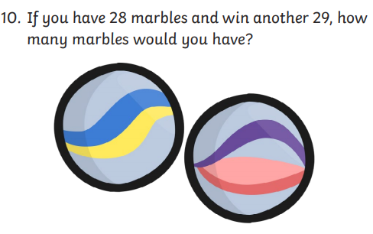

Summer Multiplication Activity Booklet
- Complete page 4 Lemon or Lime?
- Solve the multiplications first
- If the answer is even colour it yellow and if the answer is odd colour it green.
- How do you know if a number is odd or even?
- Remember
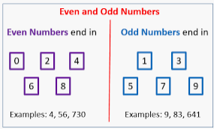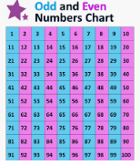
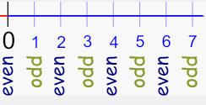
Gaeilge
- Téama: An Samhradh (Summer)
- Déan 10 as 10 https://rtejr.rte.ie/10at10/ as gaeilge
- Using Monday’s foclóir An Samhradh
- Draw a grid with 9 boxes. Choose any 9 words you like and put one word in each box. Play bingo!

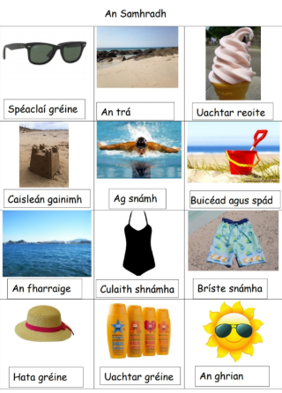

Art
- Popsicle Art
- Design and colour a popsicle you’d like to eat. Think about what flavours you like and what colour they might be.
- Here is some inspiration. Enjoy!
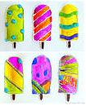
Optional Choiceboard
- Choose a different activity to do each day.

Well done for all your hard work!
Have a great weekend!

