Day Two
Week of June 22nd 2020
3rd Class Ms Hughes
For additional support see https://padlet.com/thirdclassmshughes/7nelhuv6lglw4ti6
English (My Read at Home and Get Set are available online see webpage)
- My Spelling Workbook pg 72 Unit 18
Today’s spellings: Moscow- hotel (LCWC) Write spelling 3 times.
Write 4 sentences with each spelling word.
Answer Q6 Rhyming Words pg 72 My Spelling Workbook
Answer Q7 Word Sausage pg 72 My Spelling Workbook
- My Read at home- Read the next page & answer questions orally.
- Library Book- Read your library book or listen to a story on www.storylineonline.net/library/ or Elevenses with David Walliams

Maths (Planet Maths available online see webpage)
- Mental Maths Book- Week 38 pg 110-112 complete Tuesday
Complete Tuesday for the next week that you are on. Some people are on different weeks. Complete any remaining weeks during the holidays if you can.
- Warm Up- Word Problem
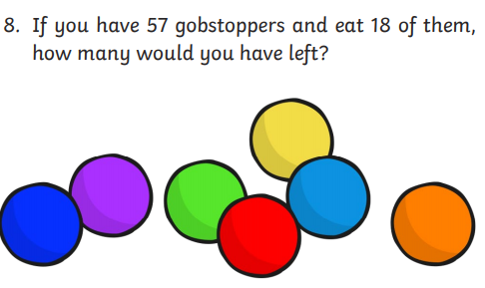
Summer Multiplication Activity Booklet
- Complete page 2 Colour by Number
- Solve the multiplications first
- Check the key at the bottom of the page to see what colour you colour the pictures.

Gaeilge
- Téama: An Samhradh (Summer)
- Déan 10 as 10 https://rtejr.rte.ie/10at10/ as gaeilge
- Complete Éadaí Samhraidh. Follow the instructions.
1.
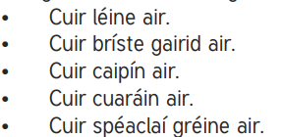
-Put a shirt on him
-Put shorts on him.
-Put a cap on him.
-Put sandals on him.
-Put sun glasses on him.

Music
- Listen to these songs that you might hear around sporting events. Have you heard them before? Why do you think they are associated with sports? Do you know anymore?
- Eye of the Tiger by Survivor https://youtu.be/FLZS3jQPnKw
- We are the Champions by Queen https://youtu.be/FLZS3jQPnKw

PE
- Tuesday is normally our PE day. Do this work out with Joe Wicks instead. It made me laugh! https://youtu.be/pTa5XTDUz7g
- Spell a family member’s name out and do the activities
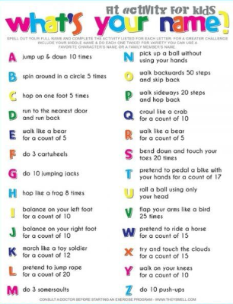
- Choose an activity you haven’t done in PE/Well-being on padlet.

