Class Work 3rd Class 29th March–3rdApril
Maths
- Mental Maths Book- Do Week 27 (pgs 80+81) One per day as usual.
- Tables Champion- Do Week 26 (pgs 35) complete ‘one day’ a day like homework.
- 3d Shape- Find examples at home if you can of a cube, cuboid, sphere, cone, cylinder, triangular prism and pyramid. Describe the shapes identifying number of faces, corners and edges.
English
- News –continue to write some personal news each day and draw a picture. This can be done like a diary as its History in the making!
- Poetry- Write an Acrostic poem about Easter like we did for Vikings and Friendship Week. E- A- S-T- E- R
This can be done in your new copy or typed. Typed poems can be emailed to me and I will post on to our webpage.
- Handwriting- Complete (pgs 62-63)
- My Spelling Workbook - (Sp Units normally completed over 2 weeks)
Complete Unit 13 spellings windy- seventeen and any Unit 13 activities not completed. If completed revise.
- Get Set – Read pages pgs 188-195
Complete activities C-G based on text in your new copy
- Library Book- read your library book or listen to a story on www.storylineonline.net/library/ or Elevenses with David Walliams
- My Read at home- read a page night

Art
- Design and make an Easter picture or card to celebrate Easter.
Email your creations to me if you’d like them to be posted on our page. Here are some ideas for inspiration!
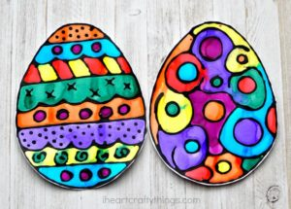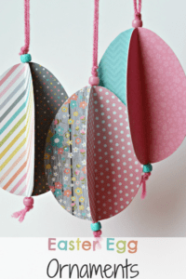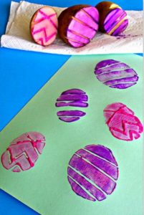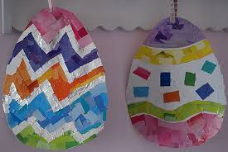
Religion
- Log in to ‘Grow in Love’ https://www.growinlove.ie/en/ and access the 3rd class materials.
- Email: trial@growinlove.ie Password: growinlove
- Select Third Class. Click into Theme 7: Holy Week and Easter
- Have a look at the resources and read pages 58-63 in the pupils book or ebook if book is at school.
Gaeilge
- Cháisc Shona! Happy Easter!
- Cartún as gaeilge www.TG4.ie Dónall Dána, Spongebob, etc
- Seanfhocail:
Márta | Is glas iad na conic I bhfad uainn | Faraway hills are greener
Aibreán | Ní neart go cur le chéile | There is strength in unity
PE
- PE with the Body Coach 9am Mon-Fri, but can be watched outside these times on youtube.
- Get moving: Choose a guided dance, stretch, workout etc on www.gonoodle.com
- Yoga: www.cosmickids.com have lovely guided yoga sessions
--------------------------------------------------------------------------------
27/3/2020
Hi Class,
I am very well and I hope you are too.
Try your best to get everything done this week if you can. Keep an eye on our webpage as I will be updating it more often. Well done to anyone who has entered the school competitions. Email me your Easter Acrostic Poems and Art creations if you like. Lovely Easter poems and art will cheer everyone up and will make our webpage look great. I’d love to see your creations!
Take care everyone and I hope to see you very soon!
I miss you all,
Ms Hughes
---------------------------------------------------------------------------------------------
Useful Websites
English: Revise some grammar on www.starfall.com
Maths: www.topmarks.com go to ‘children’s games’, ‘Maths practice’
www.ixl.com – 3rd class section
Twinkl: You can sign up for free for a month and access all resources and subjects. https://twinkl.ie/offer and enter the code: IRLTWINKHELPS

