Unit 16 Oral Language
Airport

The Airport
Airport
This oral language activity involves discussing the picture of the airport in the activity book on page 99. It may be used as preparatory work for the corresponding Aistear unit on ‘The Airport / Holidays’, it both develops vocabulary as well as introduces possible scenarios for role play.
 Begin the lesson asking pupils if they have ever been to an airport, continue with a short discussion, allowing pupils to discuss their experiences.
 Next, encourage pupils to look at the picture in the activity book in pairs and identify what they see.
 Finally, ask pupils to pose their own questions, based on what they can see in the picture.
 It is recommended that the teacher only asks some of the questions giv below, as giving pupils the opportunity to discuss the picture amongst themselves, the children will actually answer most of the questions without the teacher having to direct and over structure the questioni
en
ng.

Questions – The Airport
Where is this?
Have you ever been to an airport? Why?
Were you going on holidays or collecting someone? Can you tell us about it?
In the picture, what are the two ladies doing downstairs in the airport?
Why is the lady putting her bag on the conveyor belt? Where will her bag go? [The conveyor belt brings the lady’s bag to the special truck that w load the aeroplane]
ill
What else will the conveyor belt do? [Weigh the bag]

Cork

Spain


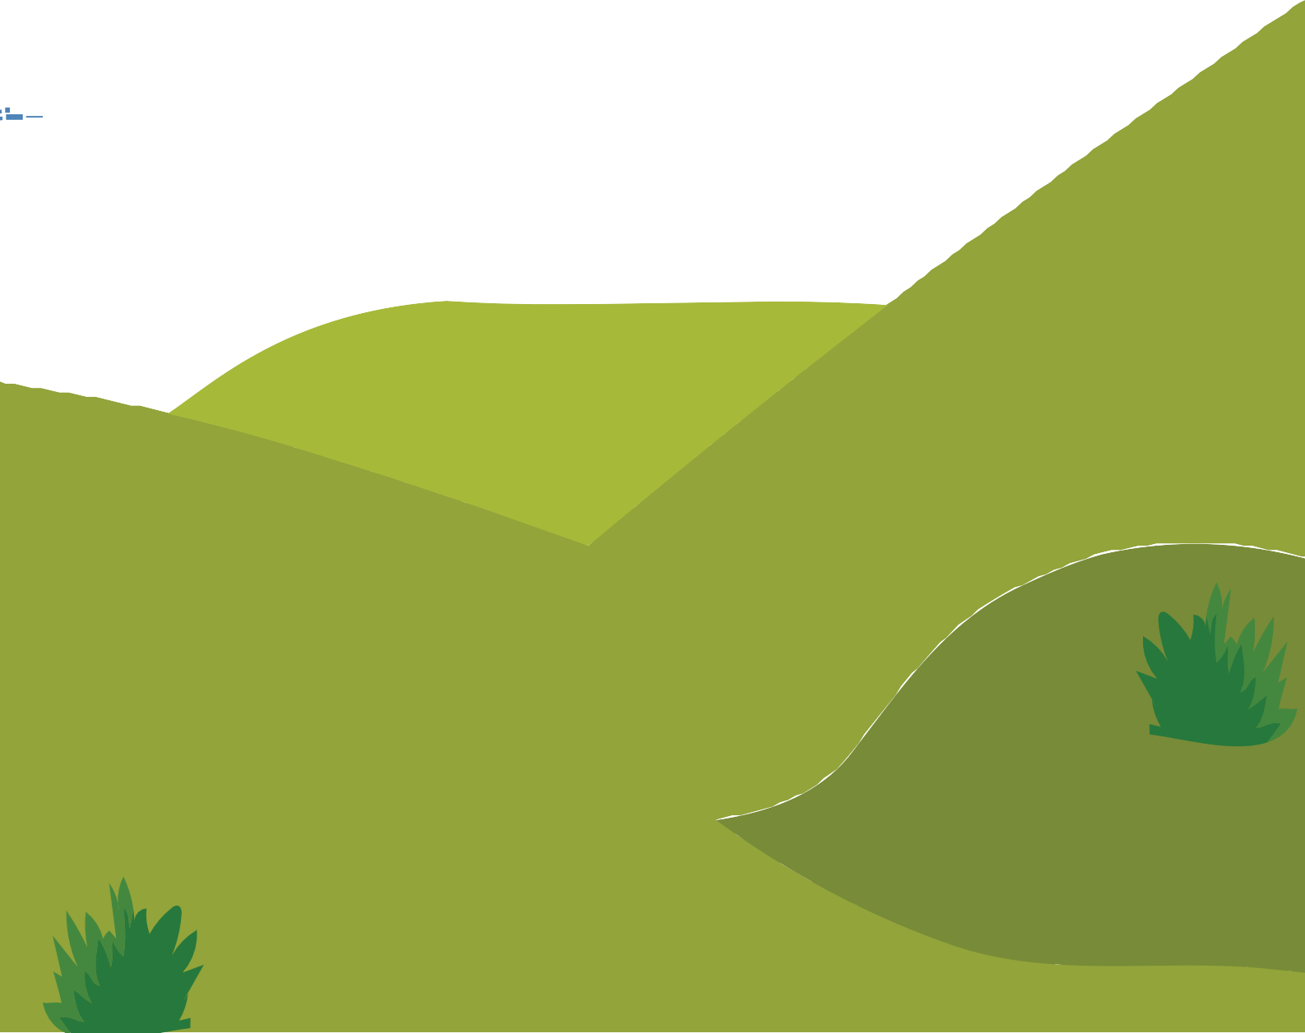
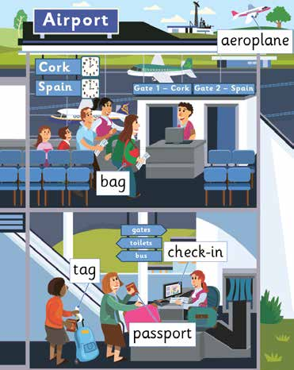
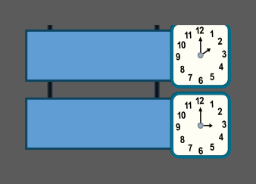


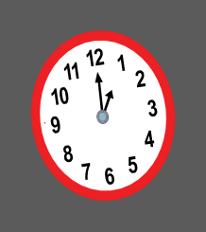

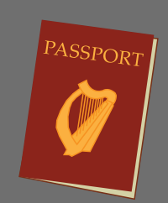






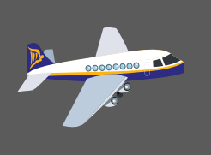
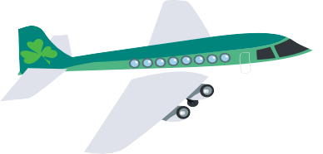

© 2017 Gill Education 1
Word Wizard, Online Resources, Junior Infants

What do we call someone who checks people onto their flight? [A flight attendant]
Airport
What will she give the lady? What jobs do check-in staff do?
 Take your name and passport
 Tick you off a list that you have arrived at the airport
 Check your passport
 Give you a boarding card
 Weigh your bag
 Check you have a tag on your bag
 Check your bag in
Where will the lady go next? [Security] What will she have to do at security?
Look at the family upstairs, where are they standing? Where are they travelling to?
Can you see the man at the desk? What is he doing? What do we call him? [A flight attendant]
What jobs does he do?
 Checks people’s boarding pass and passport
 Makes sure they only bring one bag with them on board
 Tells them when they can board the plane
If you were going on a flight what would the person checking you in ask you?
 Where are you travelling to today?

 Can I see your passport?
 Do you have any bags to check in?

Cork

Spain

Unit 16
Oral Language
What can the lady put on her bag so her bag does not get mixed up with anyone else’s?
Can the lady bring lots and lots of clothes in her bag? What do we use to weigh things in class or at home?
What is the lady at the check-in desk doing?
Airport
© 2017 Gill Education 2
Word Wizard, Online Resources, Junior Infants

Unit 16
Oral Language
 How many?
 Can you place them on the scales?
 Do you need a luggage tag / name tag?
 Here is your boarding card
 Your flight boards at …. o’clock at gate ……
Airport

If we were to pretend to have an airport with a check-in desk – what might we need? Can you explain why we might need each of these items?
Airport
 Desk
 Old computer or laptop
 Boarding cards
 Passports
 Bags / suitcases
 Weighing scales
 Luggage tags
 Signs for check-in desk
 Signs for departure gates
 Chairs
 Pilot’s hat
 Flight attendant’s hat / jacket
 Ties (with elastic)

Cork

Spain

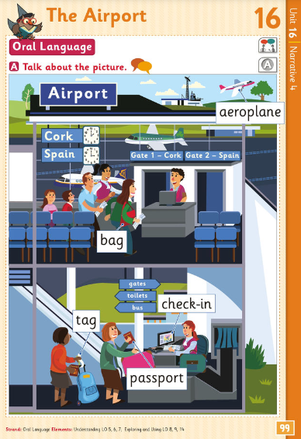© 2017 Gill Education 3
Wizard, Online Resources, Junior Infants

