Work for Monday 8th June

English :
- ‘What a Box’ Pg 41
- ‘Our News’: Try and Write 3/4 sentences.
Today is Monday.
The weather outside is ____.
This week is intercultural week.
We are going to learn about France.
- High Frequency Words – 61 – 70, check on Friday.
- Revise tricky words
Gaeilge :
Bua naCainte – Siopadóireacht – Ceacht 7
- Listen to the Rann – ’Tá Teidí ag Marcaíocht’ – listen 2/3 times and join in.
- Try to do the actions along with the song and substitute your name into the song – Tá Hugo ag Marcaíocht ...
Maths :
- Counting practise : count forwards and backwards to 20. Count in 2’s even numbers and odd numbers. What number comes before or after a number?
- Practise saying the days of the week, months of the year and seasons. What day/month/season is it?
- This week we are looking at the number line.
- Planet Maths Book: p115 – Count on the number line. On the left hand side you will be counting on 3 and on the right side you will be counting on 1. At the bottom of the page you will be writing in the missing numerals. I’ve made a video of myself doing an example, it’s on the website if you want to follow it.
Religion :
This week we are still on Theme 9: Lesson 1: A Baby’s Baptism
Watch the video ‘Baptism’ and discuss with your child.
(Go to Grow in Love webpage, use the sign in e-mail trial@growinlove.ie, password: growinlove).

SESE :
This week we are continuing with ‘The Weather’. We are going to record the weather in a chart everyday this week. We are going to be weather forecasters. I have attached a sheet to record the weather below.

Intercultural Week:
Intercultural Week was due to be held from the 3rd to 12th of June and whilst we’re not in school, we are still going to celebrate it.
We want you to do the following: Pick a Country - Do a little project on that country. To make it a little easier, I’ve chosen France for us, so if you take a look at the National Geographic page below or the YouTube link, it’ll give you lots of facts and information about France. In Senior Infants, you might like to draw the flag of France, find it on a map, draw some food from there (or buy it, Lidl make delicious croissants!) or draw a picture of a famous landmark (The Eiffel Tower, Mont St. Michel, L’Arc de Triomphe).
https://www.natgeokids.com/ie/discover/geography/countries/facts-about-france/
https://www.youtube.com/watch?v=f0mdYDCNSyM
Below I’ve linked the song Frére Jacques. Your children might like to learn a little French!
https://www.youtube.com/watch?v=BC6rvbxdywg

Alternatively, if you have a connection to a particular country, if you were born there or your parents were, why not do something based on that?
I will set it as work everyday this week, so even try and do a small bit every day. It does not have to be a big project, as we are in the Junior end. The older classes will be doing a bigger project so if you have older siblings you could work with them.
It would be wonderful to see performances of a song/ dance/ poem relating to the country too!
Happy Intercultural Week!
__________________________________________________________________________________
Work for Tuesday 9th June
PE :
30 minutes of exercise.
English :
- ‘What a Box’ Pg 42.
- Handwriting : Complete the next unfinished page in Ready to Write.
- High Frequency Words 61 - 70
- Revise Tricky Words
Gaeilge :
Bua naCainte – Siopadóireacht – Ceacht 7
- Listen to the song again ‘Tá Teidí ag Marcaíocht’.
- Play the cómhrá 7 : listen and repeat a couple of times.
- Tasc Éisteachta and Faigh an Difríocht.
Maths :
- Counting practise : count forwards and backwards to 20. Do actions for your numbers – stand up for 1, sit for 2, etc. Practise saying the days of the week, months of the year and seasons.
- Maths Activity Page: p116 & 117 – Revise 3D shapes – cube, cuboid, sphere, cylinder. Remember when you are completing the task to see how many flowers, birds and crisps etc don’t forget to include both pages.
Religion :
Theme 9: Lesson 1 : A Baby’s Baptism
Look at : The Baby is Baptised : this is the story of baby Elizabeth’s baptism. Try to make up a story to go along with the pictures.
SESE:
Fill in the weather for Tuesday on your chart.
Intercultural Day : Mini Project
__________________________________________________________________________________
Work for Wednesday 10th June
English :
- ‘What a Box’ Revise Pg 41 & 42 – aim to read independently and fluently
- Reading Practice 7 : see below. Read 3 times and draw a picture
- Handwriting : next unfinished page
- High Frequency Words – 61 – 70.
- Revise Tricky words
Gaeilge :
Bua naCainte – Siopadóireacht : Ceacht 8
- Click on to the speech bubble and watch the cómhrá 2/3 times.
- Tasc Éisteachta 8.1, 8.2
Maths :
- Counting practise : count forwards and backwards to 20. Count in 2’s even numbers and odd numbers. What number comes before or after a number?
- Practise saying the days of the week, months of the year and seasons. What day/month/season is it?
- Planet Maths: p.118 – The teddy is holding two numbers. Colour the higher number red and the lower number blue.
SESE :
Fill in Wednesday’s weather chart
Intercultural Day : Mini Project
_____________________________________________________________________________
Work for Thursday 11th June
English :
- ‘What a Box’ Pg 43
- Handwriting: Complete the next unfinished page in Ready to Write.
- Free Writing: aim for 20 minutes of free writing about anything you want.
- High Frequency Words 61-70
- Revise Tricky Words
Gaeilge :
Bua na Cainte : Siopadóireacht : Scéal : Sicín Licín
- Listen to the story of Sicín Licín. Try to join in with repetitive phrases : Tá an spear ag titim.
Maths :
- Counting practise: count forwards and backwards to 20. Do actions for your numbers – stand up for 1, sit for 2, etc. Practise saying the days of the week, months of the year and seasons.
- Revise 2D and 3D shapes.
- Today we are working on the numberline. Planet Maths – p119.
Religion :
Theme 9 : Lesson 1 : A Baby’s Baptism
Workbook Pg 52 : colour the things that Elizabeth’s family will need for her baptism.
SESE :
Fill in Thursday’s weather chart.
Intercultural Day:
Mini Project
Work for Friday12th June
PE :
30 minutes of activity – maybe a Joe Wicks session or a Cosmic Kids yoga on YouTube.
English :
- ‘What a Box’ Pg 41 - 43 : Revise the story so far. Aim to read independently.
- Drop Everything And Read – for 10 or 15 minutes. Books can be familiar or new. Children can read independently, in pairs, for a sibling, or they can be read to.
- High Frequency Words –61-70, tick today.
- Revise Tricky Words
Gaeilge :
- Revise the story Sicín Licín.
- Workbook Pg 51 : match the animals and colour
Maths :
- Counting practise : count forwards and backwards to 20. Do actions for your numbers – jump for 1, clap for 2, etc. Practise saying the days of the week, months of the year and seasons.
- Planet Maths Book – p120 – This page is very similar to the previous page. Begin on the larger number and count forward on the numberline.
SESE :
Fill in Friday’s weather chart.
Intercultural Day:
Mini Project
If you have completed your mini project, drawn a picture or a flag, or made a video of you singing Frére Jacques or a different song, I’d love to see your work. Please send to m.doyle@scoilmhuireleixlip.com
Well Done with all your hard work this week. 😊😊

Wednesday’s Reading Lesson
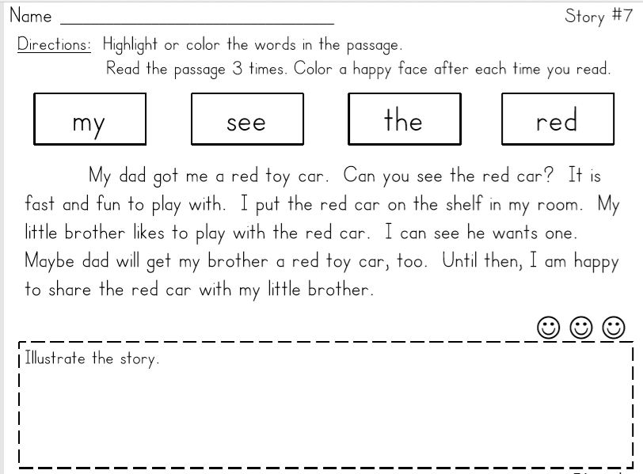

Weather Chart for the Week
What kind of weather do we have?
Monday
Tuesday
Wednesday
Thursday
Friday

