If there is a device (laptop, tablet, etc.) available to you at home, type any of the below work that you can and send it to me. If not, continue to complete the work in your copy and send me pictures of the work.

These are the links to all of the class books which are available online.

Do what you can, don’t worry if you cannot complete everything.

English
Up & Running | https://www.cjfallon.ie/
My Read at Home 5 | https://www.cjfallon.ie/
Maths
Planet Maths | https://www.folensonline.ie/
Gaeilge
Abair Liom | https://www.folensonline.ie/
Religion
Grow in Love | https://www.growinlove.ie/en/
Geography
Window on the World 5 Geography | https://www.edcolearning.ie/
Science
Window on the World 5 Science | https://www.edcolearning.ie/

Monday
English | Reading:  - My Read at home: pg. 94 + answer questions orally  - Up and Running: wordlist 5th Class Wordlist His First Flight  - Up and Running: pg. 204, 205 + 206 of the story “His First Flight”.  You can access Up & R here: https://my.cjfallon.ie/preview/student/2694  Writing:  - Wordlist: 3 x WL sentences  - My Spelling Workbook: Unit 14, LSCWC x4 spellings  - My Spelling Workbook: Exercise A
P.E/Mindfulness | Don’t forget about Joe Wicks’ daily workout: Watch and join in with Joe Wicks’ at home workout  https://www.youtube.com/channel/UCAxW1XT0iEJo0TYlRfn6rYQ  Take a few moments to write in your Time capsule Document/Journal about how you are feeling.
Maths | Planet Maths: Pg. 143 –Topic: Rules and Properties  - Play the online game: (Remember you’ll have to create a FOLENS account, details on our class page) https://www.folens.ie/login  Click resources, rules and Properties  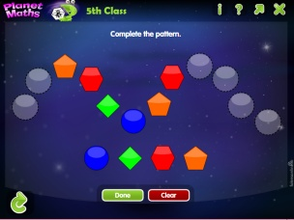  - Answer Orally: Ex. B  - Write the answers to: Ex. C and D into your copy  - Tables Champion: Monday  - Mental Maths: Monday
Religion | Read: Theme 8 Lesson 1  Answer the ‘Think about’ section with your family.  Login details are as follows:  Grow in Love: www.growinlove.ie  Email: trial@growinlove.ie  Password: growinlove  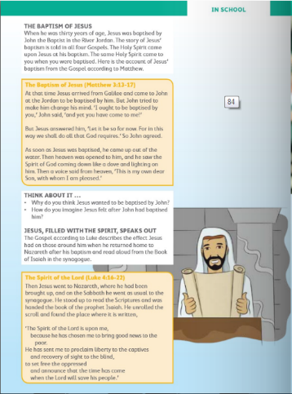  Visit: Grow in Love online with the help of a parent (only of you can) and under 5th class, Theme 8 Lesson one, you will have access to the songs for the lesson this week, along with other resources.
Gaeilge | Scéal Nua: An rinc scátála oighir  Téama: An Aimsir  You can create a Folens account (with the help of a parent) to check the pronunciations of the words. Details on our class page.  - Read the new words:  Gaeilge Béarla Gaeilge Béarla  bog mild álainn / deas lovely / nice  te hot Drochlá bad day  fuar cold ag taitneamh shining  grianmhar sunny ag spalpadh anuas beating down  scamallach cloudy ag cur báistí / fearthainne raining  fliuch wet ag séideadh blowing  tirim dry ag cur sneachta snowing  gaofar windy ag plúchadh sneachta snowing heavily (blizzard)  ceomhar foggy stoirm storm  grian sun fiáin wild  scamall cloud toirneach thunder  báisteach / fearthainn rain tintreach lightning  gaoth wind tornádó tornado  ceo fog hairicín hurricane  sioc frost crith talún earthquake  sneachta snow súnámaí tsunami  leac oighir ice dóiteán foraoise forest fire  bogha báistí rainbow tonn teasa heatwave  - Look at the picture and read the sentences. You can use the interactive account through Folens.ie and use all of the online resources like I would do in class.  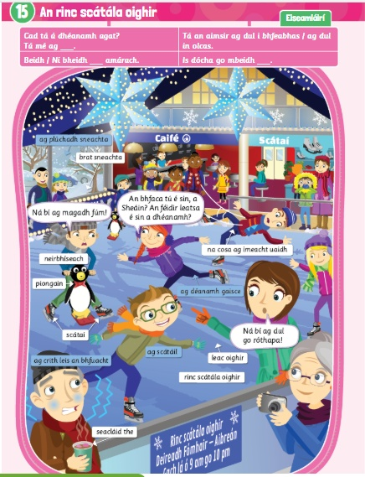
Geography | Topic: Mountains of Ireland  - Write a list off the top of your head of any of the mountains that you can think of in Ireland. Test your family members too!  - Read and locate the mountains of Ireland from your geography book below.  - Get someone in your family to ask you the questions under the map.  - Complete the worksheet on mountains of Ireland by sorting them into their province.

Tuesday
English | Reading:  - My Read at home: pg. 95  - Up and Running: wordlist  - Up and Running: pg. 207, 208 + 209 of the story “His First Flight”.  - DEAR: 10 mins  You can access Up & R here: https://my.cjfallon.ie/preview/student/2694  Writing:  - My Read at home: Answer questions pg. 95  - My Spelling Workbook: Unit 14, LSCWC x4 spellings  - My Spelling Workbook: Exercise B  - Grammar: Up & Running, pg. 211 Ex. F Verbs, into your copy/word doc.
P.E/Mindfulness | 15 mins of exercise or listening to music
Maths | Planet Maths: Pg. 144 – Rules and Properties  - Play the online game: Click resources, rules and Properties  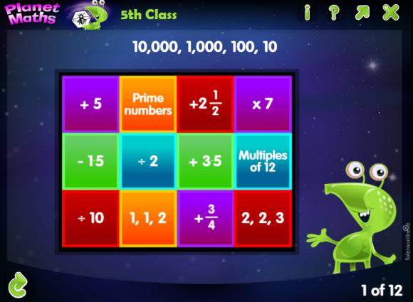  - Answer Orally: Ex. A + B  - Write the answers to: Ex. C (1-4) and D (1-3) into your copy  - Tables Champion: Tuesday  - Mental Maths: Tuesday
Religion | - Read this page and learn the “For Memorisation” section.  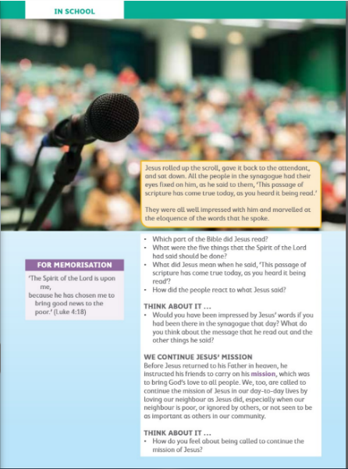
Gaeilge | - Léigh an scéal: Listen to the story being read aloud. Listen to it for a second time and say the lines with the online reader.  - Foclóir: Listen to the words and click on the correct picture.  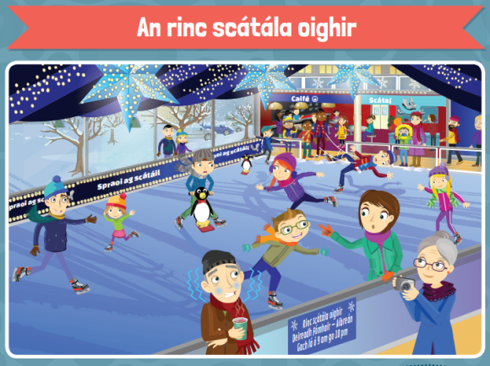  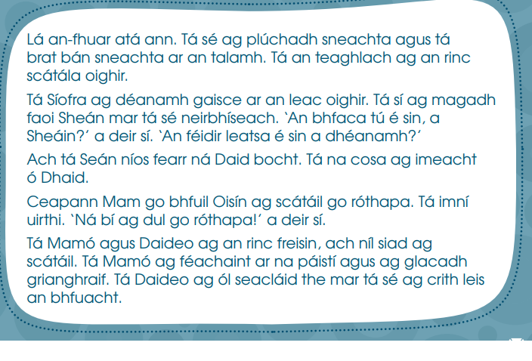
Music | - Listen to the song: We will rock you  https://www.youtube.com/watch?v=4EX5E2YbwT4  - Composing a simple body percussion sequence to accompany ‘We Will Rock You’.
Science | Topic: The Eye (This is a brilliant topic, I hope you enjoy it!!)  - What do you know about the eye?  - Look at the power point on ‘The Eye’.  - Read Chapter 6 in Window on the Word Science, The Eye.  - Complete the experiment with the help of a family member.

Wednesday
English | Reading:  - My Read at home: pg. 96  - Up and Running: wordlist  - Up and Running: Re-read the story “His First Flight”.  - DEAR: 10 mins  You can access Up & R here: https://my.cjfallon.ie/preview/student/2694  Writing:  - Up & Running: Answer the questions in Quest + Query, Ex. D  - My Spelling Workbook: Unit 14, LSCWC x4 spellings  - My Spelling Workbook: Exercise C
P.E/Mindfulness | 15 mins of exercise or listening to music
Maths | Planet Maths: Pg. 145 – Rules and Properties  - Sing your counting songs – you could make your own counting stick and ask somebody in your house to test your skip counting.  - Answer Orally: Ex. A (1 + 2) pg. 145  - Write the answers to: pg. 145 Ex. B (1+ 2), C ( 1 + 2) and D into your copy  - Tables Champion: Wednesday  - Mental Maths: Wednesday
Religion | - Read this “At Home” page and chat with family about some of the things Jesus did with the help of the Holy Spirit.  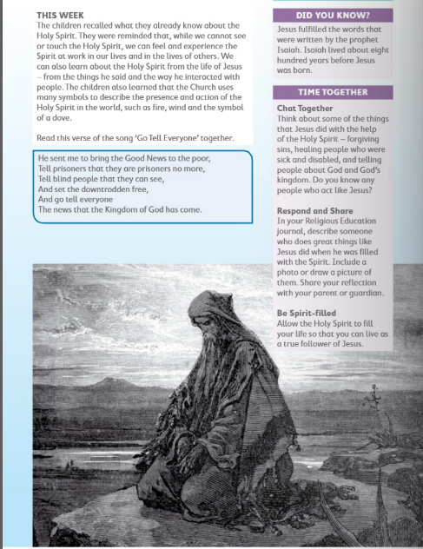
Gaeilge | - Read the new phrases:  Gaeilge Béarla  Cén sórt aimsire atá ann inniu? What is the weather like today?  Tá an aimsir ____ inniu. / Tá sé ____. The weather is ____ today. / It is ____.  Cén sórt lae atá ann? What sort of day is it?  Lá ____ atá ann. It is a ____ day.  Tá sé ag dul i bhfeabhas / ag dul in olcas. It is getting better / worse.  Tá sé ____ fós. It is still ____.  Beidh / Ní bheidh ____ amárach. It will be / will not be ____ tomorrow.  Tá súil agam go mbeidh sé ____ amárach. I hope it will be ____ tomorrow.  2. Léigh an fógra agus freagair na ceisteanna: Read the notice and answer the questions.  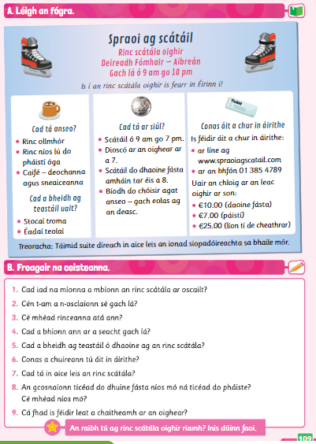
Geography | - Look at the fact sheets on the Mountains of Ireland.  - Complete this investigation; you could make it a mini project.  - Read about the different uses of mountains.

Thursday
English | Reading:  - My Read at home: pg. 97  - Up and Running: wordlist  - Persuasive Writing: Download the power point and read Persuasive Writing Power Point  - Look at the Persuasive Writing Example Poster Page.  - DEAR: 10 mins  Writing:  - ‘All Children Should Have Pets.’: Using this topic, state your opinion and two reasons.  - My Spelling Workbook: Unit 14, LSCWC x4 spellings  - My Spelling Workbook: Exercise B
P.E/Mindfulness | 15 mins of exercise or listening to music
Maths | Planet Maths: Pg. 146 – Rules and Properties  To Learn:  - Write the answers to: pg. 146, Ex. A(1 – 3) and B (1-3) into your copy.  - Answer Orally: Ex. C, pg. 146  - Tables Champion: Thursday  - Mental Maths: Thursday
Religion | - Say “The Angelus” at 12:00  - Find a quiet moment to have a conversation with God, you could write a prayer, like you have been doing in your religion Journal.
Gaeilge | 1. Léigh na frásaí nua: Read the new phrases.  Gaeilge Béarla  Is dócha go mbeidh ____. It will probably be ____.  Conas a bhíonn an aimsir (i rith an ____)? How is the weather (during ____)?  Bíonn an aimsir ____ (i rith an ____). The weather is ____ (during ____).  Cén séasúr is fearr leatsa? Which season do you prefer?  Is fearr liom an ____. I prefer the ____.  Is é ____ an séasúr is fearr liom. ____ is the season that I prefer.  An rud is mó a thaitníonn liom faoi ná ____. The thing that I like best about it is ____.  2. Léigh an fógra agus freagair na ceisteanna: Read the notice and answer the questions.
Art | Theme: Mountains, Draw, paint, colour, sketch. Here are some examples:  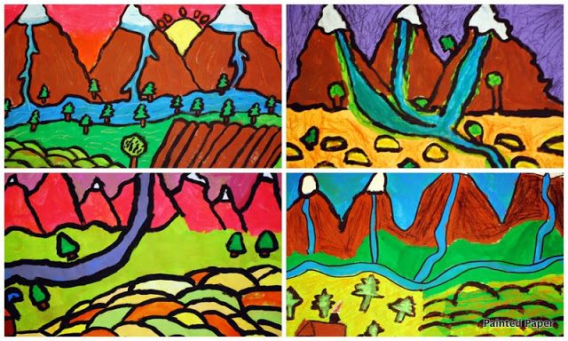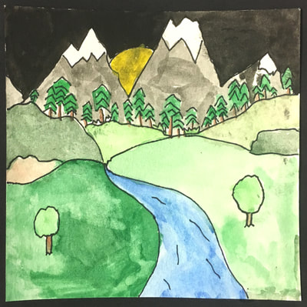
Science | Topic: The Eye  - Look at this power point on ‘The Eye number 2’.  - Draw and label a diagram of the human eye.

Friday
English | Reading:  - My Read at home: pg. 98  - Up and Running: wordlist  - DEAR: 10 mins  Writing:  - My Spelling Workbook: Unit 14, LSCWC x4 spellings  - My Spelling Workbook: Exercise E
P.E/Mindfulness | 15 mins of exercise or listening to music
Maths | Planet Maths: Pg. 144 – Rules and Properties  - Counting, skip counting (10 mins)  - Write the answers to: Ex. B and C into your copy  - Mental Maths: Friday Test
Gaeilge | Éist leis an amhrán: Listen to this song online.  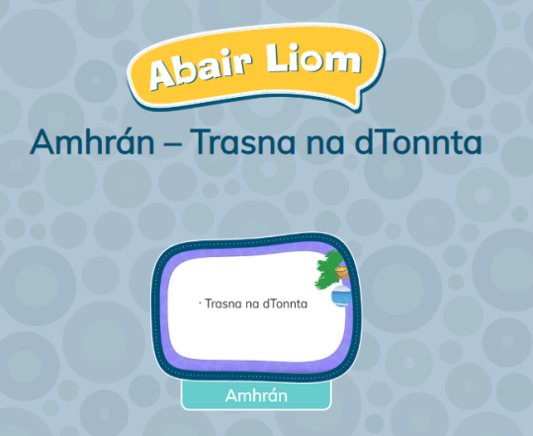  folensonline.ie:  https://content.folensonline.ie/programmes/AbairLiom/5th_class/resources/song/AL_5C_ACT_CH15_007/index.html  Abair Liom, 5th Class: Resources
Geography | - Look at the quick questions, this is the last page of this topic.  - Take the online quiz on Mountains of Ireland: https://www.purposegames.com/game/ireland-mountains-quiz-game  - Create a list/draw a picture or chat about the items you would bring.  