This is only a three-day week due to the bank holiday.
Do what you can, don’t worry if you cannot complete everything.
You can find all the resources on the school website under our class page “5th Ms Cleary”.
There is a word document with images from each of the books you will need.
But if you want to look at the online book, follow the links below.

English
Up & Running | https://www.cjfallon.ie/
My Read at Home 5 | https://www.cjfallon.ie/
Maths
Planet Maths | https://www.folensonline.ie/
Gaeilge
Abair Liom | https://www.folensonline.ie/
Religion
Grow in Love | https://www.growinlove.ie/en/
History
Window on the World 5 History | https://www.edcolearning.ie/
Science
Window on the World 5 Science | https://www.edcolearning.ie/

Wednesday

English | Reading:  - My Read at home: pg. 91 + answer questions orally  - Up and Running: wordlist The Old Forge Hotel  - Up and Running: pg. 166 -169 of the story “The Old Forge Hotel”.  You can access Up & R here: https://my.cjfallon.ie/preview/student/2694  Writing:  - Wordlist: 3 x WL sentences  - My Spelling Workbook: New Unit:15, LSCWC x4 spellings  - My Spelling Workbook: Exercise 1
Mindfulness | - Visit go noodle.com to engage in the video: “Find Peace”. You can click on the link below or access the video through your own account if you have one.  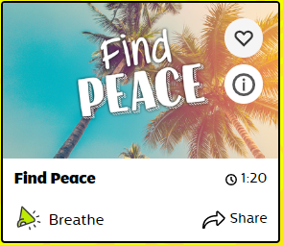 https://family.gonoodle.com/activities/find-peace?utm_content=teacher&utm_medium=949741&utm_campaign=share_link&utm_term=find-peace&utm_source=clipboard
Maths | Planet Maths: Pg. 148 Bloom’s Garden  - Write the answers: Into your copy  Q1.  Q2. (a, b, c, d)  Q3. (Only using your answers from q2)  Q4. (a, b)  Q5. (i) (a, b, c)  (ii) (a, b, c)  - Counting skip counting 2 – 12’s  - Tables Champion: Wednesday  - Mental Maths: Wednesday
Religion | Theme 8: Lesson 3  - Read: Theme 8 Lesson 3 pg. 90  - Think about & Write: Your favourite memories of any of the sacraments you celebrated in your family.  - Song: Veni Creátor Spíritus  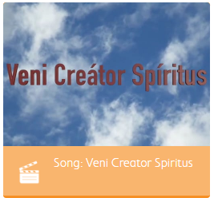  Learn Login details are as follows:  Grow in Love: www.growinlove.ie  Email: trial@growinlove.ie  Password: growinlove  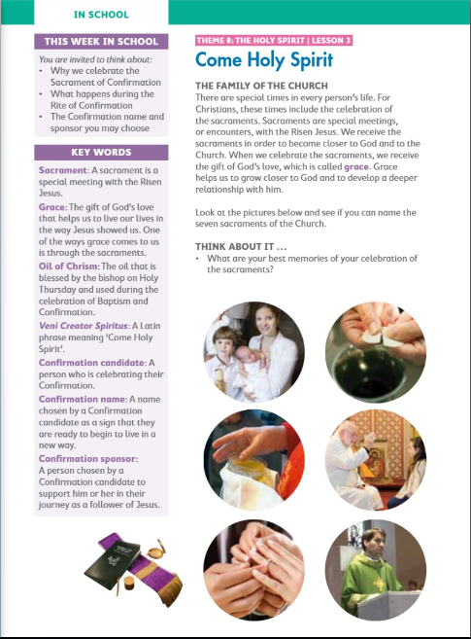  Pages can be found in the word document on the school website under our class page.
Gaeilge | Scéal Nua: Tom Crean  Téama: An Aimsir  Use folens online.ie to access the online resources. Use the word document on the school website to view the pages from the book.  - Éist leis an scéal “Tom Crean” (Listen to the information about Tom Crean before reading the story) Folens: Abair liom: Resources  - Léigh an sn scéal “Tom Crean” lch. 114  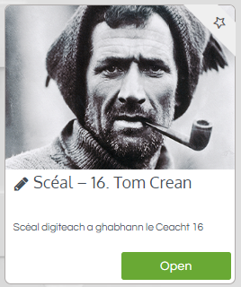  - Freagair na céisteanna ar lch. 115 (1 – 5)
History | Topic: Life in Ireland during the 1950’s  - Think about what life in Ireland was like during the 1950’s. Music? Clothes? Houses?  - Draw or write what you have imagined  - Now Read about Life in the 1950’s on page 73 - 75 of your History book. These pages can be found in the word document on the website.  - Answer the questions 1- 6

Thursday
English | Reading:  - My Read at home: pg. 92  - Up and Running: wordlist  - Up and Running: pg.170 - 173 of the story “The Old Forge Hotel”  - DEAR: 10 mins  You can access Up & R here: https://my.cjfallon.ie/preview/student/2694  Writing:  - MRH: Answer questions in copy pg. 92  - Up & Running: pg. 177 Ex. F Grammar – prepositions  - My Spelling Workbook: Unit 15, LSCWC x4 spellings  - My Spelling Workbook: Exercise 2
P.E | - Visit go noodle.com to engage in the video: “Don’t sit down”. You can click on the link below or access the video through your own account if you have one.  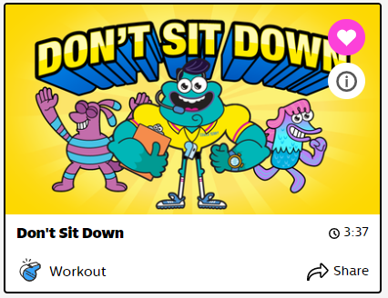  https://family.gonoodle.com/activities/dont-sit-down?utm_content=teacher&utm_medium=949741&utm_campaign=share_link&utm_term=dont-sit-down&utm_source=clipboard
Maths | Planet Maths: Pg. 149 Bloom’s Garden  - Play the online game: Click resources, representing and interpreting data  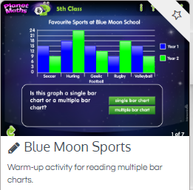  - Write the answers to: Q8. Pg. 149 into your copy.  - Tables Champion: Thursday  - Mental Maths: Thursday
Religion | - Read pg. 91 & 92  - Learn: For memorisation  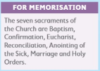  - Watch the video on the Rite of Confirmation  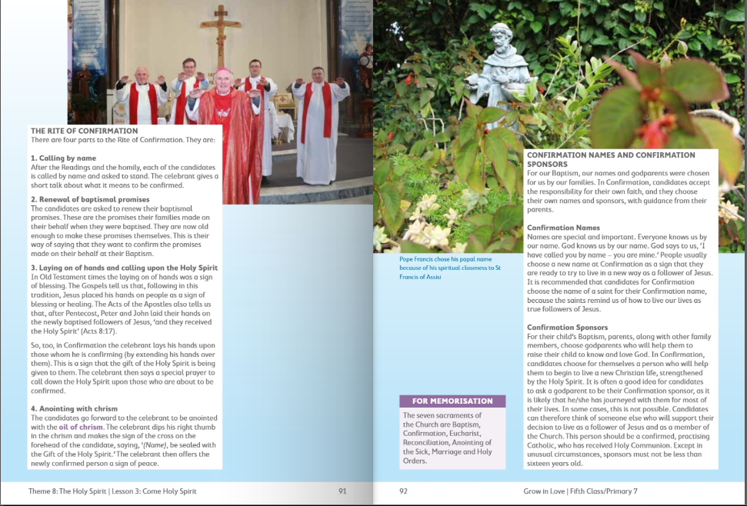
Gaeilge | - Léigh an scéal arís: Tom Crean lch. 114  - Freagair na ceisteanna: lch 115 (6-9)  - Dean ceacht C os ard: (answer Ex. C orally)  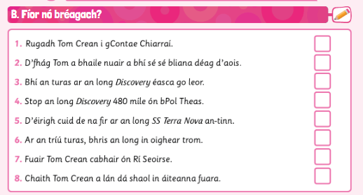
Art | Topic: Your favourite animal  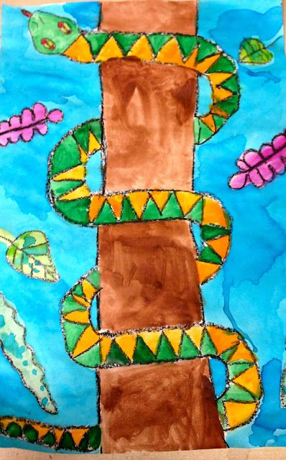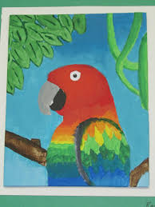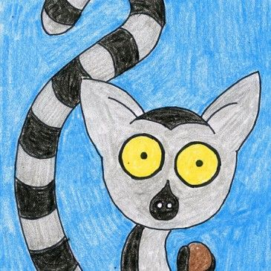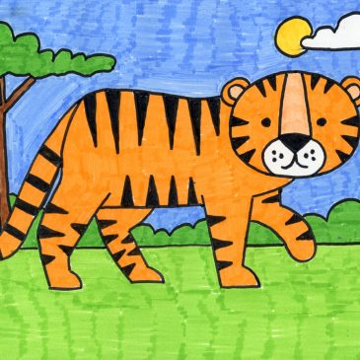  Here’s a link to learn how to draw a dragon! https://www.youtube.com/watch?v=KRAarF177Y4  Here’s a link to learn how to draw a Toucan!  https://www.youtube.com/watch?v=q4f_gQH7Skk&t=5s
History | - Study the two pictures of O’Connell Street in Dublin pg. 76. What has changed?  - Look at the power point on Life in Ireland during the 1950’s. It is located on the class page on the website.  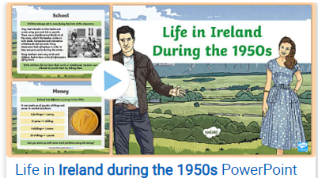  - Complete the worksheet: compare and contrasting Ireland. (Located on the school website).  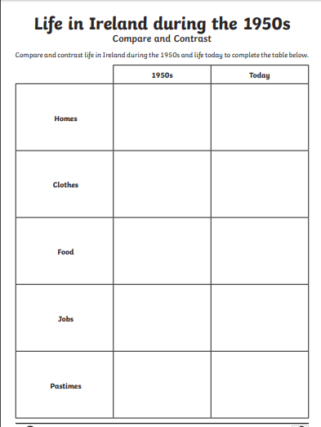

Friday
English | Reading:  - My Read at home: pg. 93  - Up and Running: wordlist  - Up and Running: pg.174 of the story “The Old Forge Hotel”  - Poem: In word document pg. 175 “Up & R” – “I’m Late for School”  - DEAR: 10 mins  You can access Up & R here: https://my.cjfallon.ie/preview/student/2694  Writing:  - Up & Running: Answer activity C questions 1- 6 pg. 176  - My Spelling Workbook: Unit 15, LSCWC x4 spellings  - My Spelling Workbook: Exercise 3
Mindfulness/P.E | Plank x 1 minute  Star jumps x 10  Burpees x 10  Frog leaps x 10  Mindful breathing x 1 minute (Close your eyes to avoid distractions)
Maths | Planet Maths: Pg. 150 ‘Mental Maths’  1. Write the answers to: pg. 150 ex. A into your copy.  3. Tables Champion: Monday/Tuesday’s from earlier that week  4. Mental Maths: Friday  5. Video: Watch the video on “Constructing a circle”. We skipped over this chapter because we know most of you do not have a compass with you at home. However, lots of questions about the circle pop up in your mental maths and throughout the maths book.  Go to folensonline.ie. and watch the video.  Click on topic, 22. The Circle.  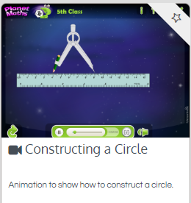
Religion | - Read this “At Home” page and chat with family about what you have learned about the sacrament of Confirmation  - Read the poem together: The Holy Spirit  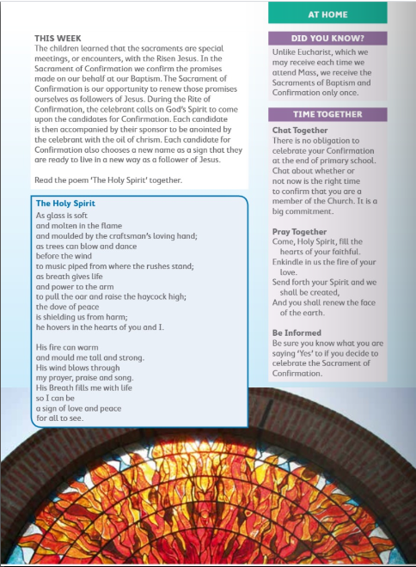
Gaeilge | - Éist agus líon na bearnaí: (go to folens online and under resources click the topic Tom Crean. You’ll find the listening activity there.  Lch. 117  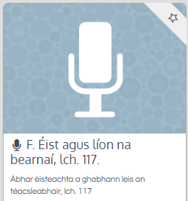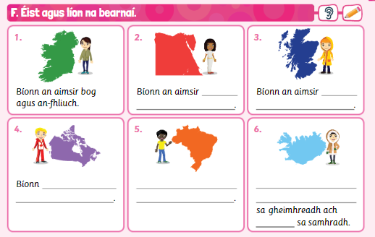  - Dean ceacht I ar lch. 119: Gramadach, na céimeanna compairáide.  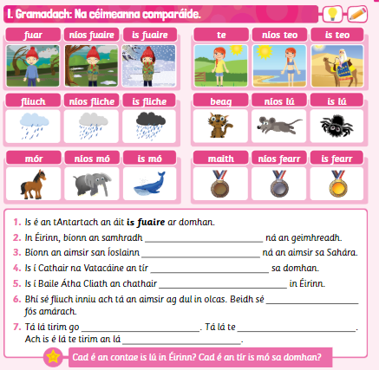
History | - Creative time: Choose one of the following to complete.