Monday 20th April
English
1. Write your news from the weekend or the Easter holidays and draw a picture.
2. Read the poem on p.72 and identify rhyming words.
3. Spelling Workbook: Unit 5 – exercise 1 and 2
4. Spelling list 23: put one word from the spelling list into a sentence

Maths
- Mental Maths: Monday p. 54 and the problem
- Tables: -4
- Complete the following sums into your copy. Remember to label your columns with T and U for tens and units.
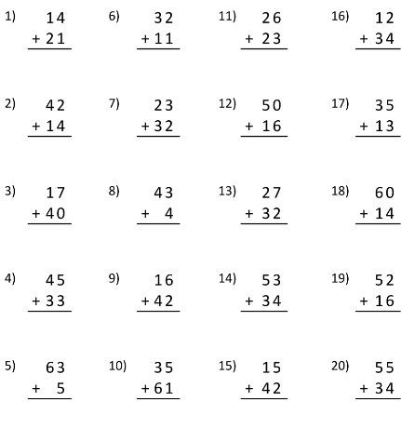
Gaeilge
1. Bua naCainte – An Teilifís Ceacht1 - Click on the yellow speech bubble and select Comhrá 1.1. Press play and listen to the lesson.
2. Go to p. 67 of your book and using the labels in the picture practise the sentence ‘Tá lampa sa seomra suí’, ‘Tá tolg sa seomra suí. ‘Tá ___ sa seomra suí’.
Don’t colour the page today, you can colour it in tomorrow! Just use it to help with the new vocabulary.
The video game controller icon at the bottom will lead you games that you can play also.
Religion Theme 8: Lesson 1
- Watch the video ‘Jesus’ Last words’ and talk about it with your family.
P.E Take part in 30 minutes of exercise; play in the garden, go for a walk or take part in one of Joe Wick’s PE lessons on YouTube.
Tuesday 21st April
English
- Read the poem ‘Yo-Yo’ on p72.
- Rewrite the poem into your copy replacing the word ‘yo-yo’ with your favourite toy.
- Spelling Workbook: Unit 5 exercise 3 and 4
- Spelling list 23: Put one word from today’s spellings into a sentence.
Maths
- Mental Maths:Tuesday p.54 and the problem
- Tables: -4
- Word Problem: the answer to the sum is 6. What is the sum?
How many possible sums can you think of? You can use + and -.
- Planet Maths: p.138
You can print this out or write the answers in a copy.
Part B: circle the ‘Ten’ in the second number. Add the ‘tens’ together.
2 tens +15 units= 3 tens and 5 units
15 units = 1 ten and 5 units.

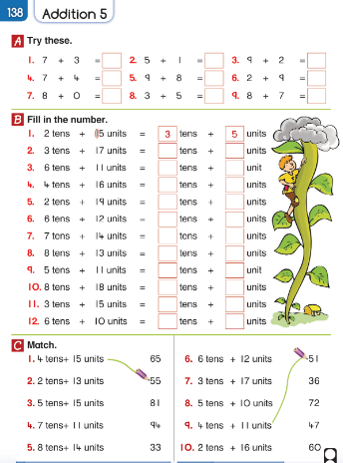

Gaeilge: Teílifís Cleacht 2 Comhrá 1.2
- An Teilifís Ceacht 1: Click on the yellow speech bubble and select Comhrá 1.2. Press play and listen to the lesson.
- Complete p.67 in Bua na Cainte
- Play one of the games by clicking the video controller.
Religion: Theme 8 Lesson 1
- Complete p.44 in G.I.L workbook.
SESE: Life Cycles
1. Look at the PowerPoint on the class page about the life cycle of a chicken.
2. Write the sentences from the picture below into your SESE copies and then draw a picture.
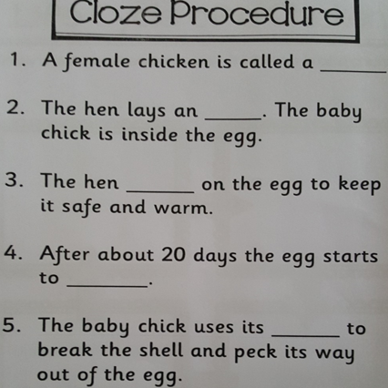

Wednesday 22nd April
English
- Read the poem on p.72
- Spelling workbook: Unit 5 exercise 5
- Spelling list 23: Put one word from today’s spellings into a sentence.
- Final sounds worksheet:
Part A: Draw the pictures on a page and write the words underneath.
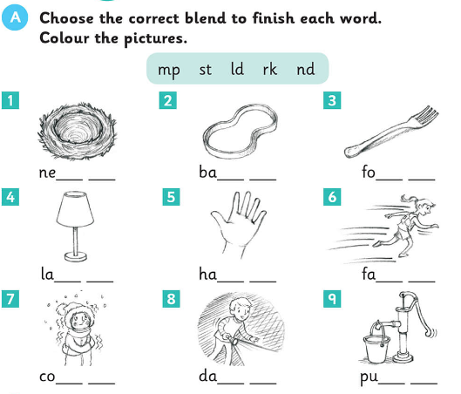

Part B: write the works into 4 lists. Can you think of another word ending in nk, sp, lt, nt? Add them to your list.
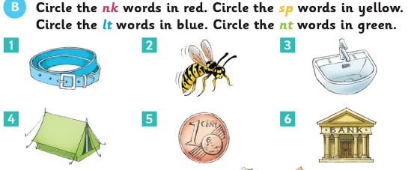
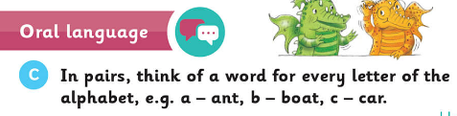
Maths
- Mental Maths: Wednesday and the problem p.54
- Tables: -4
- Word Problem: Some dogs and ducks were in the garden. There were ten legs altogether in the garden, how many dogs and ducks might there have been? Draw a picture to help you.
- Complete the following sums in your copy or on a page.
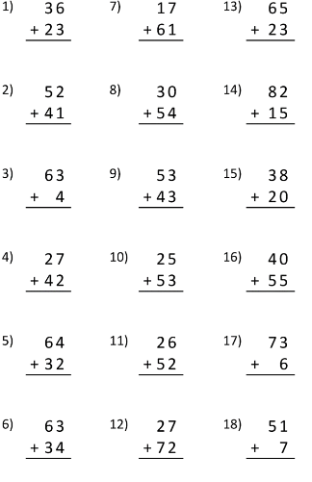

Gaeilge: Cleacht 2- comhra 2.1
- Listen to the lesson. Give someone in your family the orders ‘Cuir an teilifís ar siúl’, ‘las an solas’. (turn on the TV, turn on the lights) ‘Much an lampa’ (turn off the lamp)
- Play tasc éisteachta 2.1
- Label 3 items in your sitting room. E.g tolg, lampa, bord etc
- Listen to the song by clicking the green music icon.
Religion: Theme 8 Lesson 1
- Complete p.45 in G.I.L workbook
Art: Create a spring drawing/painting
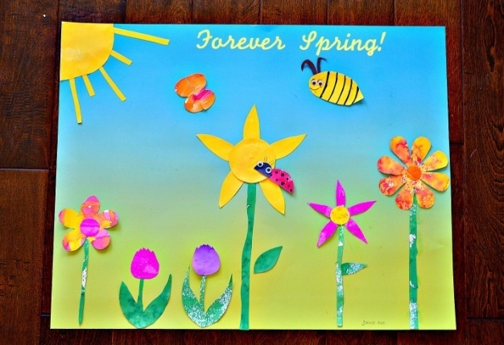

Thursday 23rd April
English
- What is this procedure for? Create the title for it and fill in the blanks.
Title: ‘How to.....
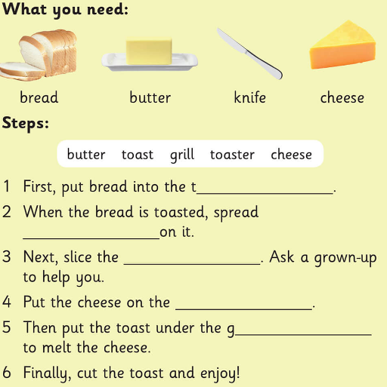

Part B: Write your own procedure
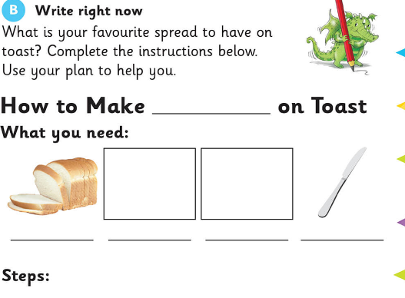
Step1:
Step 2:
Step 3:
Step 4:
Step 5:

- Spelling list 23: Put one word from today’s spelling list into a sentence.

Maths
- Mental Maths: Thursday p.55 and the problem.
- Tables: -4
- Planet Maths: p.139
Print out the page or copy it into a copy.
Remember 14= 1ten and 4units
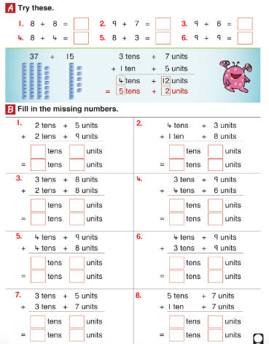

Gaeilge: Cleacht 2- comhra 2.2
- Listen to the lesson and play tasc éisteacht 2.3
- Listen to the song again by clicking the green music icon.
SESE: Answer the following questions on dandelions. Draw the picture and then label it with arrows.
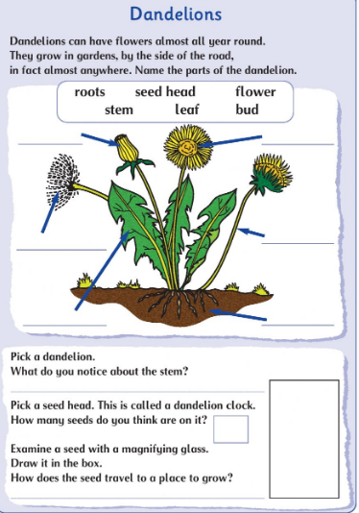

Friday 24th April
English:
- Spelling workbook: Unit 5 exercise 6 and 7
Read Oisin in Tír nÓg and answer the following questions with someone at home.
- What was special about Tír na nÓg?
- Do you think this story is true? Give reasons for your answer.
- Draw a picture of Oisin and Niamh going across the sea on a white horse.
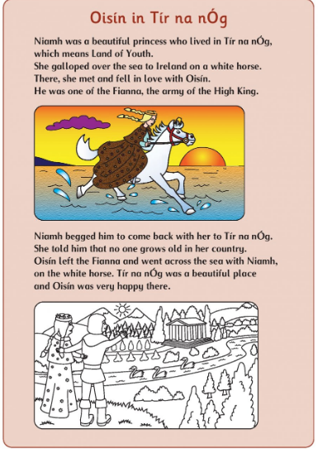
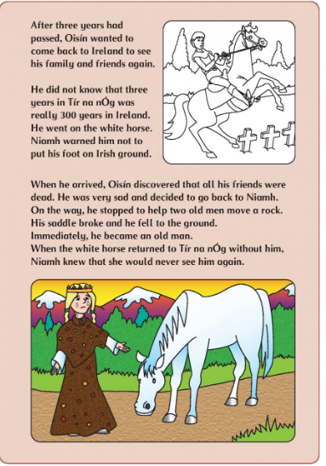
Maths
- Mental Maths: Friday Review p.55
- Table test
4-4= 6-4= 13-4= 14-4=
9-4= 10-4= 15-4= 5-4=
7-4= 12-4= 16-4= 8-4=
Gaeilge: Cleacht 3- comhra 3.2
- Listen to the lesson
- Complete the worksheet below. Print the sheet or draw 4 TV screens on a sheet and write the sentence underneath each picture.
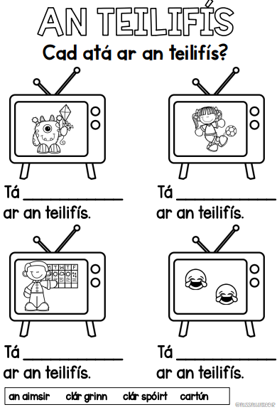
PE: Complete 30 minutes of exercise. Try one of Joe Wick’s P.E lessons on YouTube or go for a walk or play in the garden. You could also listen to some music and make up a dance routine, skip in the garden or practise some football skills!

